Transfiguration of Our Lord
February 27, 2022
Evangelical Lutheran Worship

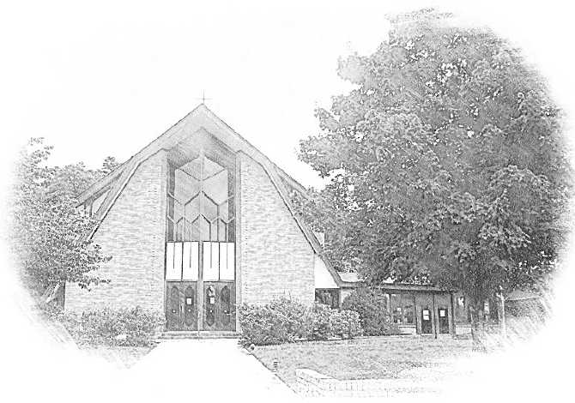

Lutheran Church of Our Saviour
Ministers: Every member of the congregation
Their Pastors: Rev. Beth Costlow & Rev. Donald Costlow
Organist: Marlon Scott
Production Staff: Harry Moose
2600 Wade Hampton Blvd
Greenville SC 29615
864.244.2836

ANNOUNCEMENTS
PRELUDE

GREETING
The grace of our Lord Jesus Christ, the love of God, and the communion of the Holy Spirit be with you all.
And also with you.

PRAYER OF THE DAY
Holy God, mighty and immortal, you are beyond our knowing, yet we see your glory in the face of Jesus Christ. Transform us into the likeness of your Son, who renewed our humanity so that we may share in his divinity, Jesus Christ our Lord, who lives and reigns with you and the Holy Spirit, one God, now and forever.
Amen.

HYMN— How Good, Lord, to Be Here ELW 671
LESSON: Exodus 34:29-35
A reading from Exodus.

²⁹Moses came down from Mount Sinai. As he came down from the mountain with the two tablets of the covenant in his hand, Moses did not know that the skin of his face shone because he had been talking with God. ³⁰When Aaron and all the Israelites saw Moses, the skin of his face was shining, and they were afraid to come near him. ³¹But Moses called to them; and Aaron and all the leaders of the congregation returned to him, and Moses spoke with them. ³²Afterward all the Israelites came near, and he gave them in commandment all that the Lord had spoken with him on Mount Sinai. ³³When Moses had finished speaking with them, he put a veil on his face; ³⁴but whenever Moses went in before the Lord to speak with him, he would take the veil off, until he came out; and when he came out, and told the Israelites what he had been commanded, ³⁵the Israelites would see the face of Moses, that the skin of his face was shining; and Moses would put the veil on his face again, until he went in to speak with him.

The Word of the Lord.

Thanks be to God.

GOSPEL: Luke 9:28-36 [37-43a]
The Holy Gospel according to St. Luke, the sixth chapter.
Glory to you, O Lord.

²⁸Now about eight days after these sayings Jesus took with him Peter and John and James, and went up on the mountain to pray. ²⁹And while he was praying, the appearance of his face changed, and his clothes became dazzling white. ³⁰Suddenly they saw two men, Moses and Elijah, talking to him. ³¹They appeared in glory and were speaking of his departure, which he was about to accomplish at Jerusalem. ³²Now Peter and his companions were weighed down with sleep; but since they had stayed awake, they saw his glory and the two men who stood with him. ³³Just as they were leaving him, Peter said to Jesus, “Master, it is good for us to be here; let us make three dwellings, one for you, one for Moses, and one for Elijah”—not knowing what he said. ³⁴While he was saying this, a cloud came and overshadowed them; and they were terrified as they entered the cloud. ³⁵Then from the cloud came a voice that said, “This is my Son, my Chosen; listen to him!” ³⁶When the voice had spoken, Jesus was found alone. And they kept silent and in those days told no one any of the things they had seen. [
³⁷On the next day, when they had come down from the mountain, a great crowd met him. ³⁸Just then a man from the crowd shouted, “Teacher, I beg you to look at my son; he is my only child. ³⁹Suddenly a spirit seizes him, and all at once he shrieks. It convulses him until he foams at the mouth; it mauls him and will scarcely leave him. ⁴⁰I begged your disciples to cast it out, but they could not.” ⁴¹Jesus answered, “You faithless and perverse generation, how much longer must I be with you and bear with you? Bring your son here.” ⁴²While he was coming, the demon dashed him to the ground in convulsions. But Jesus rebuked the unclean spirit, healed the boy, and gave him back to his father. ^{43a}And all were astounded at the greatness of God.]

The Gospel of the Lord.
Praise to you, O Christ.

CHILDREN’S SERMON

SERMON

HYMN—Alleluia, Song of Gladness ELW 318PRAYERS OF THE CHURCH
The Spirit of the Lord is poured out upon us in abundance; so we are bold to pray for the church, the world, and all that God has made.

A brief silence.

Transform us by your greatness, O God. Send us down the mountain to share joy with all people. Make us agents of change, confident that your hope will vanquish despair and your goodness will conquer evil. God of grace,
hear our prayer.
The mountains and valleys sing your praise. Dazzle us with your presence in every landscape: bluffs built by ancient glaciers, canyons carved by flowing rivers, flat horizons with uninterrupted views, and sands shaped by ocean tides. God of grace,
hear our prayer.

You love justice and establish equity. Strengthen leaders of local governments, community nonprofits, and grassroots campaigns. Bless them with gifts of integrity, creativity, and sound conscience. Build up safe and joyful communities where all people may thrive. God of grace,
hear our prayer.

Heal those who are in distress (especially). Give patience to those waiting for answers. Grant hope to those who have reached the limits of treatment. Give compassionate hearts to those who accompany loved ones through illness and uncertainty. God of grace,
hear our prayer.

Today we shout alleluia from the mountaintop; this week we enter the wilderness of Lent. Bless all who prepare and lead us in worship during this change of season: pastors, deacons, musicians, and all who contribute to our worship life (especially). God of grace,
hear our prayer.

Blessed are they who listened to Christ’s voice in this life and now rest with him (especially). Transform us from glory into glory, and give us your peace, that we do not lose heart. God of grace,
hear our prayer.

Since we have such great hope in your promises, O God, we lift these and all of our prayers to you in confidence and faith; through Jesus Christ our Savior.
Amen.

The Lord's Prayer
Lord, remember us in your kingdom and teach us to pray,
Our Father, who art in heaven,
hallowed be thy name,
thy kingdom come,
thy will be done,
on earth as it is in heaven.
Give us this day our daily bread;
and forgive us our trespasses,
as we forgive those
who trespass against us;
and lead us not into temptation,
but deliver us from evil.
For thine is the kingdom,
and the power, and the glory,
forever and ever. Amen.

BLESSING
God, who leads you in pathways of righteousness, who rejoices over you, and who calls you by name, + bless your going out and your coming in, today and forever.
Amen.

DISMISSAL
Go with Christ into a weary world. Share the good news.
Thanks be to God.

POSTLUDE
-  
From sundaysandseasons.com.
Copyright © 2022 Augsburg Fortress. All rights reserved. Reprinted by permission under Augsburg Fortress Liturgies Annual License #SAS001995.
New Revised Standard Version Bible, Copyright © 1989, Division of Christian Education of the National Council of the Churches of Christ in the United States of America. Used by permission. All rights reserved.
Revised Common Lectionary, Copyright © 1992 Consultation on Common Texts, admin Augsburg Fortress. Used by permission.
Copyright Information for Hymns:

How Good, Lord, to Be Here
Text: Joseph A. Robinson, 1858-1933, alt.
Music: POTSDAM, W. Mercer, The Church Psalter and Hymn Book, 1854

Alleluia, Song of Gladness
Text: Latin hymn, 11th cent.; tr. John Mason Neale, 1818-1866, alt.
Music: PRAISE, MY SOUL, John Goss, 1800-1880

