Third Sunday in Lent
March 20, 2022
Evangelical Lutheran Worship

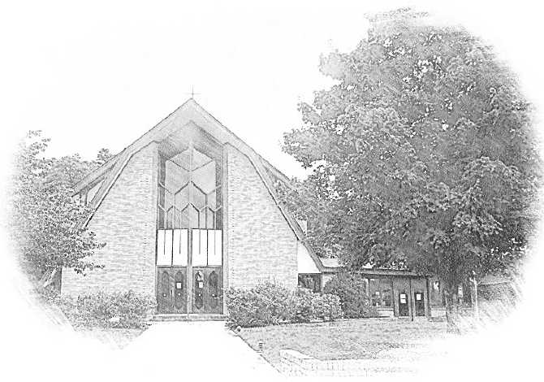

Lutheran Church of Our Saviour
Ministers: Every member of the congregation
Their Pastors: Rev. Beth Costlow & Rev. Donald Costlow
Organist: Marlon Scott
Production Staff: Harry Moose
2600 Wade Hampton Blvd
Greenville SC 29615
864.244.2836

ANNOUNCEMENTS
PRELUDE

CONFESSION AND FORGIVENESS

CONFESSION AND FORGIVENESS
All may make the sign of the cross, the sign marked at baptism, as the presiding minister begins.
In the name of God, who makes a way in the wilderness, walks with us, and guides us in our pilgrimage.
Amen.
Silence is kept for reflection. Please stand, sit, or kneel, as is comfortable for you.
Holy One,
we confess that we have wandered far from you: we have not trusted your promises, we have ignored your prophets in our own day, we have squandered our inheritance of grace, we have failed to recognize you in our midst. Have mercy on us! Forgive us and turn us again to you. Teach us to follow in your ways, assure us again of your love, and help us to love our neighbor.
Amen.

Beloved in Christ, the Word draws near to you, and all who call out to God shall be saved. In Jesus, God comes to you again and again and gathers you under wings of love. In + Jesus’ name, your sins are forgiven. God journeys with you and teaches you how to live in love.
Amen.

ENTRANCE HYMN Glorious Things of You are Spoken ELW 647
See page 6.

GREETING
The grace of our Lord Jesus Christ, the Love of God, and the communion of the Holy Spirit be with you all.
And also with you.

PRAYER OF THE DAY
Eternal God, your kingdom has broken into our troubled world through the life, death, and resurrection of your Son. Help us to hear your word and obey it, and bring your saving love to fruition in our lives, through Jesus Christ, our Savior and Lord, who lives and reigns with you and the Holy Spirit, one God, now and forever.
Amen

SECOND READING: 1 Corinthians 10:1-13
A Reading from First Corinthians.

¹I do not want you to be unaware, brothers and sisters, that our ancestors were all under the cloud, and all passed through the sea, ²and all were baptized into Moses in the cloud and in the sea, ³and all ate the same spiritual food, ⁴and all drank the same spiritual drink. For they drank from the spiritual rock that followed them, and the rock was Christ. ⁵Nevertheless, God was not pleased with most of them, and they were struck down in the wilderness.
⁶Now these things occurred as examples for us, so that we might not desire evil as they did. ⁷Do not become idolaters as some of them did; as it is written, “The people sat down to eat and drink, and they rose up to play.” ⁸We must not indulge in sexual immorality as some of them did, and twenty-three thousand fell in a single day. ⁹We must not put Christ to the test, as some of them did, and were destroyed by serpents. ¹⁰And do not complain as some of them did, and were destroyed by the destroyer. ¹¹These things happened to them to serve as an example, and they were written down to instruct us, on whom the ends of the ages have come. ¹²So if you think you are standing, watch out that you do not fall. ¹³No testing has overtaken you that is not common to everyone. God is faithful, and he will not let you be tested beyond your strength, but with the testing he will also provide the way out so that you may be able to endure it.

The word of the Lord.
Thanks be to God.

HOLY GOSPEL: Luke 13:1-9

The Holy Gospel according to St. Luke, the thirteenth chapter.
Glory to you, O Lord.

¹At that very time there were some present who told him about the Galileans whose blood Pilate had mingled with their sacrifices.²[Jesus] asked them, “Do you think that because these Galileans suffered in this way they were worse sinners than all other Galileans?³No, I tell you; but unless you repent, you will all perish as they did. ⁴Or those eighteen who were killed when the tower of Siloam fell on them—do you think that they were worse offenders than all the others living in Jerusalem? ⁵No, I tell you; but unless you repent, you will all perish just as they did.”
⁶Then he told this parable: “A man had a fig tree planted in his vineyard; and he came looking for fruit on it and found none. ⁷So he said to the gardener, ‘See here! For three years I have come looking for fruit on this fig tree, and still I find none. Cut it down! Why should it be wasting the soil?’ ⁸He replied, ‘Sir, let it alone for one more year, until I dig around it and put manure on it. ⁹If it bears fruit next year, well and good; but if not, you can cut it down.’ ”

The Gospel of the Lord.
Praise to you, O Christ.

CHILDREN’S SERMON

SERMON

HYMN OF THE DAY Rock of Ages, Cleft for Me ELW 623
See page 7.

APOSTLES’ CREED

I believe in God, the Father almighty,
creator of heaven and earth.

I believe in Jesus Christ, God’s only Son, our Lord,
who was conceived by the Holy Spirit,
born of the virgin Mary,
suffered under Pontius Pilate,
was crucified, died, and was buried;
he descended to the dead.
On the third day he rose again;
he ascended into heaven,
he is seated at the right hand of the Father,
and he will come to judge the living and the dead.

I believe in the Holy Spirit,
the holy catholic church,
the communion of saints,
the forgiveness of sins,
the resurrection of the body,
and the life everlasting. Amen.

Prayers of Intercession
Drawn close to the heart of God, we offer these prayers for the church, the world, and all who are in need.
A brief silence.
We pray for the church around the world in all its forms: for pastors, deacons, bishops, chaplains, and mission developers; for church councils, committee chairs, and all lay ministry leaders; for congregations that contemplate difficult decisions about the future of their ministry. Merciful God,
receive our prayer.

For the health of this planet and the well-being of its creatures: for lands impacted by droughts and at risk of wildfires; for fig trees and vineyards that produce fruit for our nourishment and delight; for animal habitats threatened by climate change. Merciful God,
receive our prayer.

For those called into positions of civic responsibility: for judges, attorneys, and court administrators tasked with uncovering truth and delivering justice; for activists and community leaders who cast a vision of a more compassionate and equitable society. Merciful God,
receive our prayer.

For those who call upon you for mercy: for all who live in poverty and experience hunger; for any who feel tested beyond their strength; for those who are hospitalized or near death, and for all in need of healing (especially). Merciful God,
receive our prayer.

For the advocacy efforts of this congregation: for those whose faith leads them to speak difficult truths and engage in difficult conversations with policymakers; for those who promote mercy over vengeance or retaliation. Merciful God,
receive our prayer.

For those whose earthly journeys have ended, we give thanks. With (names and) all the saints, we praise you for the forgiveness of sins, the resurrection of the body, and the life everlasting. Merciful God,
receive our prayer.

Accept the prayers we bring, O God, on behalf of a world in need, for the sake of Jesus Christ.
Amen.

The Lord's Prayer
Lord, remember us in your kingdom and teach us to pray,
Our Father, who art in heaven,
hallowed be thy name,
thy kingdom come,
thy will be done,
on earth as it is in heaven.
Give us this day our daily bread;
and forgive us our trespasses,
as we forgive those
who trespass against us;
and lead us not into temptation,
but deliver us from evil.
For thine is the kingdom,
and the power, and the glory,
forever and ever. Amen.

Blessing
You are children of God, anointed with the oil of gladness and strengthened for the journey. Almighty God,
motherly, majestic, and mighty, ☩ bless you this day and always.
Amen.

Dismissal
Go in peace. Jesus meets you on the way.
Thanks be to God!
V V V

From sundaysandseasons.com.
Copyright © 2022 Augsburg Fortress. All rights reserved. Reprinted by permission under Augsburg Fortress Liturgies Annual License #SAS001995.
New Revised Standard Version Bible, Copyright © 1989, Division of Christian Education of the National Council of the Churches of Christ in the United States of America. Used by permission. All rights reserved.
Revised Common Lectionary, Copyright © 1992 Consultation on Common Texts, admin Augsburg Fortress. Used by permission.

Copyright Information for Hymns:

Glorious Things of You Are Spoken
Text: John Newton, 1725-1807, alt.
Music: BLAENWERN, William P. Rowlands, 1860-1937

Rock of Ages, Cleft for Me
Text: Augustus M. Toplady, 1740-1778
Music: TOPLADY, Thomas Hastings, 1784-1872

