Third Sunday after Epiphany
January 23, 2022
Evangelical Lutheran Worship

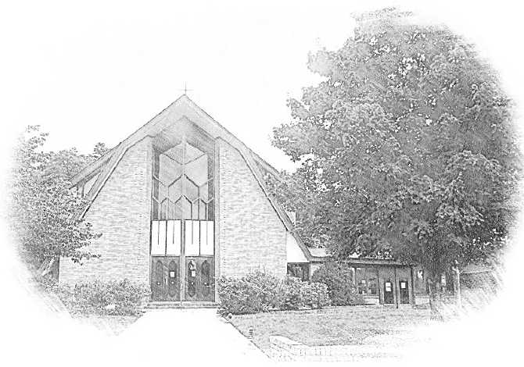

Lutheran Church of Our Saviour
Ministers: Every member of the congregation
Their Pastors: Rev. Beth Costlow & Rev. Donald Costlow
Organist: Marlon Scott
Production Staff: Harry Moose
2600 Wade Hampton Blvd
Greenville SC 29615
864.244.2836

ANNOUNCEMENTS
PRELUDE

GREETING
The grace of our Lord Jesus Christ, the Love of God, and the communion of the Holy Spirit be with you all.
And also with you.

PRAYER OF THE DAY
Blessed Lord God, you have caused the holy scriptures to be written for the nourishment of your people. Grant that we may hear them, read, mark, learn, and inwardly digest them, that, comforted by your promises, we may embrace and forever hold fast to the hope of eternal life, through your Son, Jesus Christ our Lord.
Amen.

HYMN— O, Zion Haste ELW 668
See page 6.
LESSON: 1 Corinthians 12:12-31a

A reading from First Corinthians.

¹²For just as the body is one and has many members, and all the members of the body, though many, are one body, so it is with Christ. ¹³For in the one Spirit we were all baptized into one body—Jews or Greeks, slaves or free—and we were all made to drink of one Spirit.
¹⁴Indeed, the body does not consist of one member but of many. ¹⁵If the foot would say, “Because I am not a hand, I do not belong to the body,” that would not make it any less a part of the body. ¹⁶And if the ear would say, “Because I am not an eye, I do not belong to the body,” that would not make it any less a part of the body. ¹⁷If the whole body were an eye, where would the hearing be? If the whole body were hearing, where would the sense of smell be? ¹⁸But as it is, God arranged the members in the body, each one of them, as he chose. ¹⁹If all were a single member, where would the body be? ²⁰As it is, there are many members, yet one body. ²¹The eye cannot say to the hand, “I have no need of you,” nor again the head to the feet, “I have no need of you.” ²²On the contrary, the members of the body that seem to be weaker are indispensable, ²³and those members of the body that we think less honorable we clothe with greater honor, and our less respectable members are treated with greater respect; ²⁴whereas our more respectable members do not need this. But God has so arranged the body, giving the greater honor to the inferior member, ²⁵that there may be no dissension within the body, but the members may have the same care for one another. ²⁶If one member suffers, all suffer together with it; if one member is honored, all rejoice together with it.
²⁷Now you are the body of Christ and individually members of it. ²⁸And God has appointed in the church first apostles, second prophets, third teachers; then deeds of power, then gifts of healing, forms of assistance, forms of leadership, various kinds of tongues. ²⁹Are all apostles? Are all prophets? Are all teachers? Do all work miracles? ³⁰Do all possess gifts of healing? Do all speak in tongues? Do all interpret? ^{31a}But strive for the greater gifts.

The Word of the Lord.

Thanks be to God.

GOSPEL: Luke 4:14-21
The Holy Gospel according to St. Luke, the fourth chapter.
Glory to you, O Lord.

¹⁴Then Jesus, filled with the power of the Spirit, returned to Galilee, and a report about him spread through all the surrounding country. ¹⁵He began to teach in their synagogues and was praised by everyone.
¹⁶When he came to Nazareth, where he had been brought up, he went to the synagogue on the sabbath day, as was his custom. He stood up to read, ¹⁷and the scroll of the prophet Isaiah was given to him. He unrolled the scroll and found the place where it was written:
¹⁸“The Spirit of the Lord is upon me,
because he has anointed me
to bring good news to the poor.
He has sent me to proclaim release to the captives
and recovery of sight to the blind,
to let the oppressed go free,
¹⁹to proclaim the year of the Lord’s favor.”
²⁰And he rolled up the scroll, gave it back to the attendant, and sat down. The eyes of all in the synagogue were fixed on him. ²¹Then he began to say to them, “Today this scripture has been fulfilled in your hearing.”

The Gospel of the Lord.
Praise to you, O Christ.

CHILDREN’S SERMON

SERMON

HYMN—Arise, Your Light Has Come
PRAYERS OF THE CHURCH
The Spirit of the Lord is poured out upon us in abundance; so we are bold to pray for the church, the world, and all that God has made.

A brief silence.

You reveal yourself to us in the reading of scripture. Fulfill your word through the faithful witness of your church. Send us out to bring your liberating good news to all people. God of grace,
hear our prayer.

All creation proclaims your handiwork. Teach us to love the intricate and beautiful bodies that you have created. Bless tiny insects, enormous whales, and every creature in between. Sustain species at risk of extinction. God of grace,
hear our prayer.

You desire that there be no dissension among us. Where we are divided in our society, nation, or world, come quickly to reunite us into one body. Ease conflict, dispel violence, and bring an end to war. God of grace,
hear our prayer.

Anoint with your Spirit all who seek your favor. Grant provision and justice for people living in poverty, people living with disability, those living with pain, or those living under oppression (especially). God of grace,
hear our prayer.

Build up the body of Christ in this place. Bless the variety of ministries in this congregation (especially). Empower us to freely welcome and deeply value each person who enters into worship and ministry among us. God of grace,
hear our prayer.

In thanksgiving we lift before you the saints for whom the promise of salvation has now been fulfilled. Tend to those who mourn (especially). Bring us together in your everlasting glory. God of grace,
hear our prayer.

Since we have such great hope in your promises, O God, we lift these and all of our prayers to you in confidence and faith; through Jesus Christ our Savior.
Amen.

The Lord's Prayer
Lord, remember us in your kingdom and teach us to pray,
Our Father, who art in heaven,
hallowed be thy name,
thy kingdom come,
thy will be done,
on earth as it is in heaven.
Give us this day our daily bread;
and forgive us our trespasses,
as we forgive those
who trespass against us;
and lead us not into temptation,
but deliver us from evil.
For thine is the kingdom,
and the power, and the glory,
forever and ever. Amen.

BLESSING
The God of hope fill us with all joy and peace in believing, so that we may abound in hope by the power of the Holy Spirit, through Christ Jesus, the Word made flesh.
Amen.

DISMISSAL
Go in peace. Rejoice in Christ our Savior.
Thanks be to God.

POSTLUDE

-  
From sundaysandseasons.com.
Copyright © 2022 Augsburg Fortress. All rights reserved. Reprinted by permission under Augsburg Fortress Liturgies Annual License #SAS001995.
New Revised Standard Version Bible, Copyright © 1989, Division of Christian Education of the National Council of the Churches of Christ in the United States of America. Used by permission. All rights reserved.
Revised Common Lectionary, Copyright © 1992 Consultation on Common Texts, admin Augsburg Fortress. Used by permission.
Copyright Information for Hymns:

O Zion, Haste
Text: Mary A. Thomson, 1834-1923
Music: ANGELIC SONGS, James Welch, 1837-1901

Arise, Your Light Has Come
Text: Ruth Duck, b.1947
Music: FESTAL SONG, William H. Walter, 1825-1893
Text © 1992 GIA Publications, Inc., 7404 S. Mason Ave., Chicago, IL 60638. www.giamusic.com. 800.442.3358 All rights reserved. Used by permission.
Duplication in any form prohibited without permission or valid license from copyright administrator.

O, Zion Haste

