Sixth Sunday after Epiphany
February 13, 2022
Evangelical Lutheran Worship

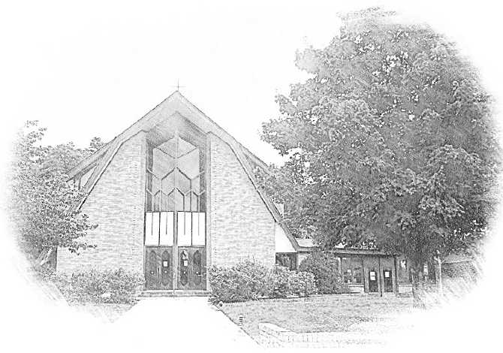

Lutheran Church of Our Saviour
Ministers: Every member of the congregation
Their Pastors: Rev. Beth Costlow & Rev. Donald Costlow
Organist: Marlon Scott
Production Staff: Harry Moose
2600 Wade Hampton Blvd
Greenville SC 29615
864.244.2836

ANNOUNCEMENTS
PRELUDE

GREETING
The grace of our Lord Jesus Christ, the love of God, and the communion of the Holy Spirit be with you all.
And also with you.

PRAYER OF THE DAY
Living God, in Christ you make all things new. Transform the poverty of our nature by the riches of your grace, and in the renewal of our lives make known your glory, through Jesus Christ, our Savior and Lord.
Amen.

HYMN— Praise to the Lord, the Almighty ELW 858
See page 5.

LESSON: 1 Corinthians 15:12-20
A reading from First Corinthians.

¹²Now if Christ is proclaimed as raised from the dead, how can some of you say there is no resurrection of the dead? ¹³If there is no resurrection of the dead, then Christ has not been raised; ¹⁴and if Christ has not been raised, then our proclamation has been in vain and your faith has been in vain. ¹⁵We are even found to be misrepresenting God, because we testified of God that he raised Christ—whom he did not raise if it is true that the dead are not raised. ¹⁶For if the dead are not raised, then Christ has not been raised. ¹⁷If Christ has not been raised, your faith is futile and you are still in your sins. ¹⁸Then those also who have died in Christ have perished. ¹⁹If for this life only we have hoped in Christ, we are of all people most to be pitied.
²⁰But in fact Christ has been raised from the dead, the first fruits of those who have died.

The Word of the Lord.

Thanks be to God.

GOSPEL: Luke 6:17-26
The Holy Gospel according to St. Luke, the sixth chapter.
Glory to you, O Lord.

¹⁷[Jesus] came down with [the twelve] and stood on a level place, with a great crowd of his disciples and a great multitude of people from all Judea, Jerusalem, and the coast of Tyre and Sidon.¹⁸They had come to hear him and to be healed of their diseases; and those who were troubled with unclean spirits were cured. ¹⁹And all in the crowd were trying to touch him, for power came out from him and healed all of them.
²⁰Then he looked up at his disciples and said:
“Blessed are you who are poor,
for yours is the kingdom of God.
²¹“Blessed are you who are hungry now,
for you will be filled.
“Blessed are you who weep now,
for you will laugh.
²²“Blessed are you when people hate you, and when they exclude you, revile you, and defame you on account of the Son of Man. ²³Rejoice in that day and leap for joy, for surely your reward is great in heaven; for that is what their ancestors did to the prophets.
²⁴“But woe to you who are rich,
for you have received your consolation.
²⁵“Woe to you who are full now,
for you will be hungry.
“Woe to you who are laughing now,
for you will mourn and weep.
²⁶“Woe to you when all speak well of you, for that is what their ancestors did to the false prophets.”

The Gospel of the Lord.
Praise to you, O Christ.

CHILDREN’S SERMON

SERMON

HYMN—Blest Are They ELW 728
See page 6.

PRAYERS OF THE CHURCH
The Spirit of the Lord is poured out upon us in abundance; so we are bold to pray for the church, the world, and all that God has made.

A brief silence.

Blessed are those whose trust is in you. Strengthen the faith of those who profess your name and bring reassurance to those who doubt or fear. Through your church speak continued blessing into the world. God of grace,
hear our prayer.

Those who trust in you are like trees planted by streams of water. Bless fruit trees with an abundant harvest. Protect rainforests from destruction. Restore land that has eroded after deforestation. Resurrect woodlands after forest fires. God of grace,
hear our prayer.

Search the hearts of those who govern, that they lead with humility. Inspire leaders to collaborate on policies that protect people and the planet. Sustain truth-tellers and social movements that challenge society to become more honest and just. God of grace,
hear our prayer.

Send your blessings of mercy upon those who long for consolation. Tend to those struggling with poverty, unemployment, or uncertainty. Provide for all who are hungry. Console those who face persecution. Grant peace to all who suffer (especially). God of grace,
hear our prayer.

Renew this congregation in our shared mission. As we plan and dream for the future you are preparing, inspire us by the examples of Martin Luther and all the reformers. Bless new projects and new ministry partnerships. God of grace,
hear our prayer.

Christ is raised from the dead, and so we cling to the hope of the resurrection. We praise you for the lives of the saints who lived and died in the hope of eternal life with you (especially). God of grace,
hear our prayer.

Since we have such great hope in your promises, O God, we lift these and all of our prayers to you in confidence and faith; through Jesus Christ our Savior.
Amen.

The Lord's Prayer
Lord, remember us in your kingdom and teach us to pray,
Our Father, who art in heaven,
hallowed be thy name,
thy kingdom come,
thy will be done,
on earth as it is in heaven.
Give us this day our daily bread;
and forgive us our trespasses,
as we forgive those
who trespass against us;
and lead us not into temptation,
but deliver us from evil.
For thine is the kingdom,
and the power, and the glory,
forever and ever. Amen.

BLESSING
God, who leads you in pathways of righteousness, who rejoices over you, and who calls you by name, + bless your going out and your coming in, today and forever.
Amen.

DISMISSAL
Go with Christ into a weary world. Share the good news.
Thanks be to God.

POSTLUDE
-  
From sundaysandseasons.com.
Copyright © 2022 Augsburg Fortress. All rights reserved. Reprinted by permission under Augsburg Fortress Liturgies Annual License #SAS001995.
New Revised Standard Version Bible, Copyright © 1989, Division of Christian Education of the National Council of the Churches of Christ in the United States of America. Used by permission. All rights reserved.
Revised Common Lectionary, Copyright © 1992 Consultation on Common Texts, admin Augsburg Fortress. Used by permission.
Copyright Information for Hymns:

Praise to the Lord, the Almighty
Text: Joachim Neander, 1650-1680; tr. Catherine Winkworth, 1827-2878, alt.
Music: LOBE DEN HERREN, Ernewerten Gesangbuch, Part II, Stralsund, 1665

Canticle of the Turning
Text: Rory Cooney, b. 1952, based on the Magnificat
Music: STAR OF COUNTY DOWN, Irish Traditional
Text © 1990 GIA Publications, Inc., 7404 Mason Ave., Chicago, IL 60638. www.giamusic.com. 800.442.3358
Duplication in any form prohibited without permission or valid license from copyright administrator.

