Seventh Sunday after Epiphany
February 20, 2022
Evangelical Lutheran Worship

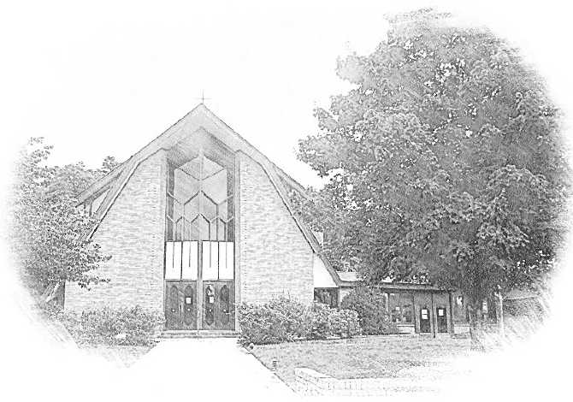

Lutheran Church of Our Saviour
Ministers: Every member of the congregation
Their Pastors: Rev. Beth Costlow & Rev. Donald Costlow
Organist: Marlon Scott
Production Staff: Harry Moose
2600 Wade Hampton Blvd
Greenville SC 29615
864.244.2836

ANNOUNCEMENTS
PRELUDE

GREETING
The grace of our Lord Jesus Christ, the love of God, and the communion of the Holy Spirit be with you all.
And also with you.

PRAYER OF THE DAY
O Lord Jesus, make us instruments of your peace, that where there is hatred, we may sow love, where there is injury, pardon, and where there is despair, hope. Grant, O divine master, that we may seek to console, to understand, and to love in your name, for you live and reign with the Father and the Holy Spirit, one God, now and forever.
Amen.

HYMN— Word of God, Come Down on Earth ELW 510
See page 6.

LESSON: 1 Corinthians 15:35-38, 42-50
A reading from First Corinthians.

³⁵But someone will ask, “How are the dead raised? With what kind of body do they come?” ³⁶Fool! What you sow does not come to life unless it dies. ³⁷And as for what you sow, you do not sow the body that is to be, but a bare seed, perhaps of wheat or of some other grain. ³⁸But God gives it a body as he has chosen, and to each kind of seed its own body.
⁴²So it is with the resurrection of the dead. What is sown is perishable, what is raised is imperishable. ⁴³It is sown in dishonor, it is raised in glory. It is sown in weakness, it is raised in power. ⁴⁴It is sown a physical body, it is raised a spiritual body. If there is a physical body, there is also a spiritual body. ⁴⁵Thus it is written, “The first man, Adam, became a living being”; the last Adam became a life-giving spirit. ⁴⁶But it is not the spiritual that is first, but the physical, and then the spiritual. ⁴⁷The first man was from the earth, a man of dust; the second man is from heaven. ⁴⁸As was the man of dust, so are those who are of the dust; and as is the man of heaven, so are those who are of heaven. ⁴⁹Just as we have borne the image of the man of dust, we will also bear the image of the man of heaven.
⁵⁰What I am saying, brothers and sisters, is this: flesh and blood cannot inherit the kingdom of God, nor does the perishable inherit the imperishable.

The Word of the Lord.

Thanks be to God.

GOSPEL: Luke 6:27-38
The Holy Gospel according to St. Luke, the sixth chapter.
Glory to you, O Lord.

[Jesus said:] ²⁷“But I say to you that listen, Love your enemies, do good to those who hate you, ²⁸bless those who curse you, pray for those who abuse you. ²⁹If anyone strikes you on the cheek, offer the other also; and from anyone who takes away your coat do not withhold even your shirt. ³⁰Give to everyone who begs from you; and if anyone takes away your goods, do not ask for them again. ³¹Do to others as you would have them do to you.
³²“If you love those who love you, what credit is that to you? For even sinners love those who love them. ³³If you do good to those who do good to you, what credit is that to you? For even sinners do the same. ³⁴If you lend to those from whom you hope to receive, what credit is that to you? Even sinners lend to sinners, to receive as much again. ³⁵But love your enemies, do good, and lend, expecting nothing in return. Your reward will be great, and you will be children of the Most High; for he is kind to the ungrateful and the wicked. ³⁶Be merciful, just as your Father is merciful.
³⁷“Do not judge, and you will not be judged; do not condemn, and you will not be condemned. Forgive, and you will be forgiven; ³⁸give, and it will be given to you. A good measure, pressed down, shaken together, running over, will be put into your lap; for the measure you give will be the measure you get back.”

The Gospel of the Lord.
Praise to you, O Christ.

CHILDREN’S SERMON

SERMON

HYMN—God, When Human Bonds are Broken ELW 603
PRAYERS OF THE CHURCH
The Spirit of the Lord is poured out upon us in abundance; so we are bold to pray for the church, the world, and all that God has made.

A brief silence.

You teach us to love our neighbors and enemies alike. Encourage your church to follow the leading of your love, especially when it is risky or difficult. Help us to show mercy just as we have first received mercy. God of grace,
hear our prayer.
Nurture fields that lie dormant, resting until it is time to bloom again. Bless farmers and all who cultivate fields and urban gardens. Give favorable weather for planting. Bring forth from buried seed an abundant harvest, and guard against famine and disease. God of grace,
hear our prayer.

Look upon our world with mercy, that we delight in an abundance of peace. Protect all whose lives are marred by war and civil unrest. Release political prisoners and amplify the voices that challenge us to seek forgiveness and pursue nonviolence. God of grace,
hear our prayer.

Your people cry out for mercy. Console hearts that long for forgiveness. Mend broken relationships. Heal bodies that suffer chronic pain or illness. Strengthen and deliver all whose spirits are troubled (especially). God of grace,
hear our prayer.

You bind us together into one family. Teach us to forgive one another and to resolve conflicts with humility and patience. Bless families of all shapes and sizes, and show love to those who are lonely or grieving. God of grace,
hear our prayer.

We praise you for the saints who have inherited the fullness of your kingdom (especially). As you have raised them to imperishable and eternal life, sustain us in faith by the promise of resurrection. God of grace,
hear our prayer.

Since we have such great hope in your promises, O God, we lift these and all of our prayers to you in confidence and faith; through Jesus Christ our Savior.
Amen.

The Lord's Prayer
Lord, remember us in your kingdom and teach us to pray,
Our Father, who art in heaven,
hallowed be thy name,
thy kingdom come,
thy will be done,
on earth as it is in heaven.
Give us this day our daily bread;
and forgive us our trespasses,
as we forgive those
who trespass against us;
and lead us not into temptation,
but deliver us from evil.
For thine is the kingdom,
and the power, and the glory,
forever and ever. Amen.

BLESSING
God, who leads you in pathways of righteousness, who rejoices over you, and who calls you by name, + bless your going out and your coming in, today and forever.
Amen.

DISMISSAL
Go with Christ into a weary world. Share the good news.
Thanks be to God.

POSTLUDE
-  
From sundaysandseasons.com.
Copyright © 2022 Augsburg Fortress. All rights reserved. Reprinted by permission under Augsburg Fortress Liturgies Annual License #SAS001995.
New Revised Standard Version Bible, Copyright © 1989, Division of Christian Education of the National Council of the Churches of Christ in the United States of America. Used by permission. All rights reserved.
Revised Common Lectionary, Copyright © 1992 Consultation on Common Texts, admin Augsburg Fortress. Used by permission.
Copyright Information for Hymns:

Word of God, Come Down on Earth
Text: James Quinn, SJ, b. 1919
Music: LIEBSTER JESU, WIR SIND HIER, Johann R. Ahle, 1625-1673
Text © James Quinn, SJ. Selah Publishing Co., Inc., North American agent, www.selahpub.com
Duplication in any form prohibited without permission or valid license from copyright administrator.

God, When Human Bonds are Broken
Text: Fred Kaan, b. 1929
Music: MERTON, William H. Monk, 1823-1889
Text © 1989 Hope Publishing Company, Carol Stream, IL 60188. All rights reserved. Used by permission.
Duplication in any form prohibited without permission or valid license from copyright administrator.

