Second Sunday in Lent
March 13, 2022
Evangelical Lutheran Worship

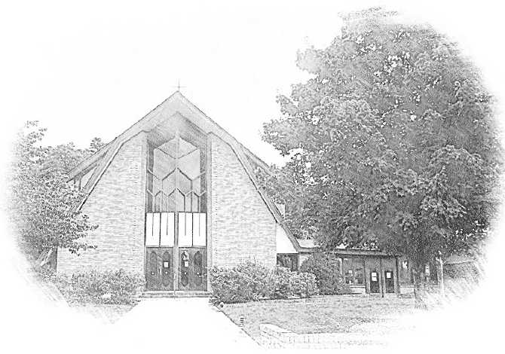

Lutheran Church of Our Saviour
Ministers: Every member of the congregation
Their Pastors: Rev. Beth Costlow & Rev. Donald Costlow
Organist: Marlon Scott
Production Staff: Harry Moose
2600 Wade Hampton Blvd
Greenville SC 29615
864.244.2836

ANNOUNCEMENTS
PRELUDE

CONFESSION AND FORGIVENESS

CONFESSION AND FORGIVENESS
All may make the sign of the cross, the sign marked at baptism, as the presiding minister begins.
In the name of God, who makes a way in the wilderness, walks with us, and guides us in our pilgrimage.
Amen.
Silence is kept for reflection. Please stand, sit, or kneel, as is comfortable for you.
Holy One,
we confess that we have wandered far from you: we have not trusted your promises, we have ignored your prophets in our own day, we have squandered our inheritance of grace, we have failed to recognize you in our midst. Have mercy on us! Forgive us and turn us again to you. Teach us to follow in your ways, assure us again of your love, and help us to love our neighbor.
Amen.

Beloved in Christ, the Word draws near to you, and all who call out to God shall be saved. In Jesus, God comes to you again and again and gathers you under wings of love. In + Jesus’ name, your sins are forgiven. God journeys with you and teaches you how to live in love.
Amen.

ENTRANCE HYMN Around You, O Lord Jesus ELW 468
See page 6.

GREETING
The grace of our Lord Jesus Christ, the Love of God, and the communion of the Holy Spirit be with you all.
And also with you.

PRAYER OF THE DAY
God of the covenant, in the mystery of the cross you promise everlasting life to the world. Gather all peoples into your arms, and shelter us with your mercy, that we may rejoice in the life we share in your Son, Jesus Christ, our Savior and Lord, who lives and reigns with you and the Holy Spirit, one God, now and forever.
Amen

SECOND READING: Philippians 3:17--4:1
A Reading from Philippians.

¹⁷Brothers and sisters, join in imitating me, and observe those who live according to the example you have in us. ¹⁸For many live as enemies of the cross of Christ; I have often told you of them, and now I tell you even with tears. ¹⁹Their end is destruction; their god is the belly; and their glory is in their shame; their minds are set on earthly things. ²⁰But our citizenship is in heaven, and it is from there that we are expecting a Savior, the Lord Jesus Christ. ²¹He will transform the body of our humiliation that it may be conformed to the body of his glory, by the power that also enables him to make all things subject to himself. ^{4:1}Therefore, my brothers and sisters, whom I love and long for, my joy and crown, stand firm in the Lord in this way, my beloved.

The word of the Lord.
Thanks be to God.
HOLY GOSPEL: Luke 13:31-35

The Holy Gospel according to St. Luke, the thirteenth chapter.
Glory to you, O Lord.

³¹At that very hour some Pharisees came and said to [Jesus,] “Get away from here, for Herod wants to kill you.” ³²He said to them, “Go and tell that fox for me, ‘Listen, I am casting out demons and performing cures today and tomorrow, and on the third day I finish my work. ³³Yet today, tomorrow, and the next day I must be on my way, because it is impossible for a prophet to be killed outside of Jerusalem.’ ³⁴Jerusalem, Jerusalem, the city that kills the prophets and stones those who are sent to it! How often have I desired to gather your children together as a hen gathers her brood under her wings, and you were not willing! ³⁵See, your house is left to you. And I tell you, you will not see me until the time comes when you say, ‘Blessed is the one who comes in the name of the Lord.’ ”

The Gospel of the Lord.
Praise to you, O Christ.

CHILDREN’S SERMON

SERMON

HYMN OF THE DAY Thy Holy Wings ELW 613
See page 7.

APOSTLES’ CREED

I believe in God, the Father almighty,
creator of heaven and earth.

I believe in Jesus Christ, God’s only Son, our Lord,
who was conceived by the Holy Spirit,
born of the virgin Mary,
suffered under Pontius Pilate,
was crucified, died, and was buried;
he descended to the dead.
On the third day he rose again;
he ascended into heaven,
he is seated at the right hand of the Father,
and he will come to judge the living and the dead.

I believe in the Holy Spirit,
the holy catholic church,
the communion of saints,
the forgiveness of sins,
the resurrection of the body,
and the life everlasting. Amen.

Prayers of Intercession
Drawn close to the heart of God, we offer these prayers for the church, the world, and all who are in need.

A brief silence.

You gather the church into a community of mercy and grace. Unify Christians around the globe in efforts to proclaim good news even in the face of opposition and to protect those whose lives are imperiled by the gospel. Merciful God,
receive our prayer.

You create the entire universe and call it good. Hinder those who would cause further destruction to our planet’s fragile ecosystems, and augment the calls of those who advocate for thoughtful stewardship of the earth’s resources. Merciful God,
receive our prayer.

You raise up leaders committed to love and justice. Nurture in those who govern patience to receive criticism, openness to new ideas, and courage to change course when needed for the sake of the common good. Merciful God,
receive our prayer.

You hear us when we cry to you. Attend to those expecting a child, and console those who have experienced miscarriage. Comfort veterans enduring post-traumatic stress. Shield those endangered by domestic violence. Uphold those who are ill or grieving (especially). Merciful God,
receive our prayer.

You kindle faith that moves us into action. Guide children and adults preparing for baptism or confirmation. Empower Sunday school teachers, confirmation leaders, and parents who share their faith with younger generations. Give us all a renewed sense of vocation. Merciful God,
receive our prayer.

You welcome us into your heavenly realm. We give thanks for those whose labors on earth are ended and who now rest with you. On the final day, gather all of us, with them, in your loving arms. Merciful God,
receive our prayer.

Accept the prayers we bring, O God, on behalf of a world in need, for the sake of Jesus Christ.
Amen.

The Lord's Prayer
Lord, remember us in your kingdom and teach us to pray,
Our Father, who art in heaven,
hallowed be thy name,
thy kingdom come,
thy will be done,
on earth as it is in heaven.
Give us this day our daily bread;
and forgive us our trespasses,
as we forgive those
who trespass against us;
and lead us not into temptation,
but deliver us from evil.
For thine is the kingdom,
and the power, and the glory,
forever and ever. Amen.

Blessing
You are children of God, anointed with the oil of gladness and strengthened for the journey. Almighty God,
motherly, majestic, and mighty, ☩ bless you this day and always.
Amen.
Dismissal
Go in peace. Jesus meets you on the way.
Thanks be to God!
V V V

From sundaysandseasons.com.
Copyright © 2022 Augsburg Fortress. All rights reserved. Reprinted by permission under Augsburg Fortress Liturgies Annual License #SAS001995.
New Revised Standard Version Bible, Copyright © 1989, Division of Christian Education of the National Council of the Churches of Christ in the United States of America. Used by permission. All rights reserved.
Revised Common Lectionary, Copyright © 1992 Consultation on Common Texts, admin Augsburg Fortress. Used by permission.

Copyright Information for Hymns:

Around You, O Lord Jesus
Text: Frans Mikael Franzen, 1772-1847; tr. composite
Music: O JESU, AN DE DINA, H. Thomisson, Den danske Psalmebog, 1569
Text © 1978 Lutheran Book of Worship, admin. Augsburg Fortress
Duplication in any form prohibited without permission or valid license from copyright administrator.

Thy Holy Wings
Text: Carolina Sandell Berg, 1832-1903, sts. 1, 3; Gracia Grindal, b. 1943, st. 2; tr. composite
Music: BRED DINA VIDA VINGAR, Swedish Folk Tune; arr. hymnal version
Text © 1983 Gracia Grindal, Selah Publishing Co., inc., agent, www.selahpub.com
Arr. © 2006 Augsburg Fortress
Duplication in any form prohibited without permission or valid license from copyright administrator.

