Resurrection of Our Lord/Easter Day
April 17, 2022
Evangelical Lutheran Worship

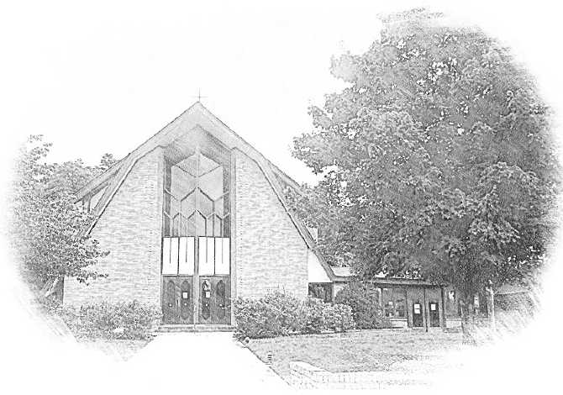

Lutheran Church of Our Saviour
Ministers: Every member of the congregation
Their Pastors: Rev. Beth Costlow & Rev. Donald Costlow
Organist: Marlon Scott
Production Staff: Harry Moose
2600 Wade Hampton Blvd
Greenville SC 29615
864.244.2836

WELCOME AND ANNOUNCEMENTS
PRELUDE from Marlon

The resurrection proclamation is repeated three times, with more enthusiasm each time.

Alleluia! Christ is risen!
His is risen indeed! Alleluia!

Thanksgiving for Baptism

All may make the sign of the cross, the sign marked at baptism, as the presiding minister begins.
Alleluia! Christ is risen.
Christ is risen indeed. Alleluia!
Refreshed by the resurrection life we share in Christ, let us give thanks for the gift of baptism.

Water may be poured into the font as the presiding minister gives thanks.
We thank you, risen Christ, for these waters where you make us new, leading us from death to life, from tears to joy. We bless you, risen Christ, that your Spirit comes to us in the grace-filled waters of rebirth,
like rains to our thirsting earth, like streams that revive our souls, like cups of cool water shared with strangers. Breathe your peace on your church when we hide in fear. Clothe us with your mercy and forgiveness. Send us companions on our journey as we share your life. Make us one, risen Christ.
Cleanse our hearts. Shower us with life. To you be given all praise, with the Holy Spirit, in the glory of God, now and forever.
Amen.

ENTRANCE HYMN – Jesus Christ is Risen Today ELW #365
See page 5.

Greeting
The grace of our Lord Jesus Christ, the love of God, and the communion of the Holy Spirit be with you all.
And also with you.

PRAYER OF THE DAY
Let us pray. O God, you gave your only Son to suffer death on the cross for our redemption, and by his glorious resurrection you delivered us from the power of death. Make us die every day to sin, that we may live with him forever in the joy of the resurrection, through your Son, Jesus Christ our Lord, who lives and reigns with you and the Holy Spirit, one God, now and forever.
Amen.

First Reading: Acts 10:34-43

³⁴Peter began to speak to [the people]: “I truly understand that God shows no partiality, ³⁵but in every nation anyone who fears him and does what is right is acceptable to him. ³⁶You know the message he sent to the people of Israel, preaching peace by Jesus Christ—he is Lord of all. ³⁷That message spread throughout Judea, beginning in Galilee after the baptism that John announced: ³⁸how God anointed Jesus of Nazareth with the Holy Spirit and with power; how he went about doing good and healing all who were oppressed by the devil, for God was with him. ³⁹We are witnesses to all that he did both in Judea and in Jerusalem. They put him to death by hanging him on a tree; ⁴⁰but God raised him on the third day and allowed him to appear, ⁴¹not to all the people but to us who were chosen by God as witnesses, and who ate and drank with him after he rose from the dead. ⁴²He commanded us to preach to the people and to testify that he is the one ordained by God as judge of the living and the dead. ⁴³All the prophets testify about him that everyone who believes in him receives forgiveness of sins through his name.”

The word of the Lord.
Thanks be to God.

HOLY GOSPEL: Luke 24:1-12

The Holy Gospel according to St. Luke, the 12th chapter.
Glory to you, O Lord.

¹On the first day of the week, at early dawn, [the women] came to the tomb, taking the spices that they had prepared. ²They found the stone rolled away from the tomb, ³but when they went in, they did not find the body. ⁴While they were perplexed about this, suddenly two men in dazzling clothes stood beside them. ⁵The women were terrified and bowed their faces to the ground, but the men said to them, “Why do you look for the living among the dead? He is not here, but has risen. ⁶Remember how he told you, while he was still in Galilee, ⁷that the Son of Man must be handed over to sinners, and be crucified, and on the third day rise again.” ⁸Then they remembered his words, ⁹and returning from the tomb, they told all this to the eleven and to all the rest. ¹⁰Now it was Mary Magdalene, Joanna, Mary the mother of James, and the other women with them who told this to the apostles. ¹¹But these words seemed to them an idle tale, and they did not believe them. ¹²But Peter got up and ran to the tomb; stooping and looking in, he saw the linen cloths by themselves; then he went home, amazed at what had happened.

The Gospel of the Lord.
Praise to you, O Christ.

SERMON

HYMN OF THE DAY— The Strife is O’er, the Battle Done ELW #366
See page 6.

Prayers of Intercession
On this day of resurrection joy, let us offer our prayers for ourselves, our neighbors, and our world.

A brief silence.

Renewing God, the good news of your resurrection changed the world. Give church leaders and all the baptized the same excitement as the women at the tomb, and inspire us to share your abundant life. Merciful God,
receive our prayer.

Sustaining God, your creation abounds with signs of new life in budding trees and newborn creatures. Provide fertile soil, ample sunlight, and nourishing rain for the growth of plants, and provide farmers with a plentiful harvest. Merciful God,
receive our prayer.

Sheltering God, strengthen and sustain all who support vulnerable people across the world (especially). Empower government agencies and international organizations that provide for refugees and migrants forced to leave their homelands. Merciful God,
receive our prayer.

Encouraging God, you do a new thing among us. We pray for those gripped by fear and anxiety or who suffer in any way (especially). Send us as your healing presence to places of hunger, pain, illness, or overwhelming sorrow. Merciful God,
receive our prayer.

Surprising God, you offer endless ways for us to delight in your grace. Give this community of faith a sense of joy and wonder in exploring new avenues of faith formation, worship, and discipleship. Merciful God,
receive our prayer.
Resurrecting God, you make us alive in Christ. Thank you for blessing us with faithful witnesses who now rest in you (especially). Merciful God,
receive our prayer.

We offer to you these petitions and those we carry in our hearts, trusting in your abundant and ever-present mercy.
Amen.

The Lord's Prayer
Our Father, who art in heaven,
hallowed be thy name,
thy kingdom come,
thy will be done,
on earth as it is in heaven.
Give us this day our daily bread;
and forgive us our trespasses,
as we forgive those
who trespass against us;
and lead us not into temptation,
but deliver us from evil.
For thine is the kingdom,
and the power, and the glory,
forever and ever. Amen.

BLESSING
God, the Author of life, Christ, the living Cornerstone, and the life-giving Spirit of adoption, + bless you now and forever.
Amen.

DISMISSAL
Alleluia! Christ is risen.
Christ is risen indeed. Alleluia!

Go in peace. Tell what God has done.
Thanks be to God. Alleluia!

POSTLUDE

V V V

From sundaysandseasons.com.
Copyright © 2021 Augsburg Fortress. All rights reserved. Reprinted by permission under Augsburg Fortress Liturgies Annual License #SAS001995.
New Revised Standard Version Bible, Copyright © 1989, Division of Christian Education of the National Council of the Churches of Christ in the United States of America. Used by permission. All rights reserved.
Revised Common Lectionary, Copyright © 1992 Consultation on Common Texts, admin Augsburg Fortress. Used by permission.
Copyright information for hymns:
Jesus Christ is Risen Today
Text: Latin caron, 14th cent., sts. 1-3; tr. J. Walsh, Lyra Davidica, 1708, alt.; Charles Wesleh, 1707-1788, st. 4.
Music: EASTER HYMN, J. Walsh, Lyra Davidica, 1708

The Strife is O’er
Text: Symphonia Sirenum, Koln, 169; tr. Francis Pott, 1832-1909
Music: VICTORY, Giovanni Pierluigi da Palestrina, 1525-1594; arr. William H. Monk, 1823-1889

