Sunday of the Passion/Palm Sunday
April 10, 2022
Evangelical Lutheran Worship

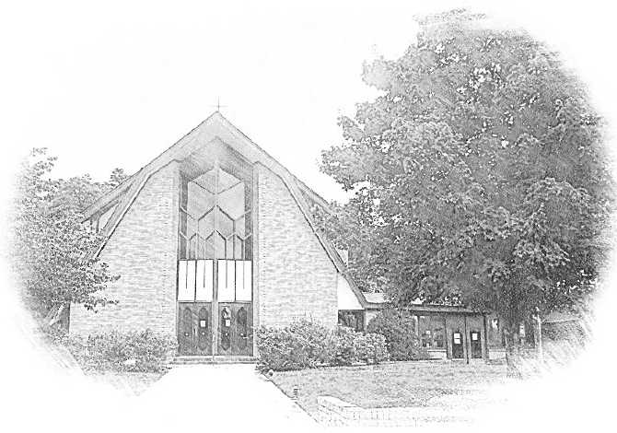

Lutheran Church of Our Saviour
Ministers: Every member of the congregation
Their Pastors: Rev. Beth Costlow & Rev. Donald Costlow
Organist: Marlon Scott
Production Staff: Harry Moose
2600 Wade Hampton Blvd
Greenville SC 29615
864.244.2836

ANNOUNCEMENTS
PRELUDE

Acclamation
The presiding minister begins (repeated three times):
Blessed is the one who comes in the name of the Lord.
Hosanna in the highest.

Processional Gospel: Luke 19:28-40
An assisting minister or the presiding minister reads the processional gospel.
The holy gospel according to St. Luke the 19th chapter.
Glory to you, O Lord.

²⁸After he had said this, [Jesus] went on ahead, going up to Jerusalem.
²⁹When he had come near Bethphage and Bethany, at the place called the Mount of Olives, he sent two of the disciples, ³⁰saying, “Go into the village ahead of you, and as you enter it you will find tied there a colt that has never been ridden. Untie it and bring it here. ³¹If anyone asks you, ‘Why are you untying it?’ just say this, ‘The Lord needs it.’ ” ³²So those who were sent departed and found it as he had told them. ³³As they were untying the colt, its owners asked them, “Why are you untying the colt?” ³⁴They said, “The Lord needs it.” ³⁵Then they brought it to Jesus; and after throwing their cloaks on the colt, they set Jesus on it. ³⁶As he rode along, people kept spreading their cloaks on the road. ³⁷As he was now approaching the path down from the Mount of Olives, the whole multitude of the disciples began to praise God joyfully with a loud voice for all the deeds of power that they had seen, ³⁸saying,
“Blessed is the king
who comes in the name of the Lord!
Peace in heaven,
and glory in the highest heaven!”
³⁹Some of the Pharisees in the crowd said to him, “Teacher, order your disciples to stop.” ⁴⁰He answered, “I tell you, if these were silent, the stones would shout out.”

The gospel of the Lord.
Praise to you, O Christ.

hymn- All Glory, Laud, and Honor ELW 344

Prayer of the Day
Let us pray. Everlasting God, in your endless love for the human race you sent our Lord Jesus Christ to take on our nature and to suffer death on the cross. In your mercy enable us to share in his obedience to your will and in the glorious victory of his resurrection, who lives and reigns with you and the Holy Spirit, one God, now and forever.
Amen.

LESSON: Philippians 2:5-11

A reading from Philippians.

⁵Let the same mind be in you that was in Christ Jesus,
⁶who, though he was in the form of God,
did not regard equality with God
as something to be exploited,
⁷but emptied himself,
taking the form of a slave,
being born in human likeness.
And being found in human form,
⁸he humbled himself
and became obedient to the point of death—
even death on a cross.
⁹Therefore God also highly exalted him
and gave him the name
that is above every name,
¹⁰so that at the name of Jesus
every knee should bend,
in heaven and on earth and under the earth,
¹¹and every tongue should confess
that Jesus Christ is Lord,
to the glory of God the Father.

The word of the Lord
Thanks be to God

GOSPEL: 23:1-49

The Holy Gospel according to St. Luke, the 22nd and 23rd chapters.
Glory to you, O Lord.

¹Then the assembly rose as a body and brought Jesus before Pilate. ²They began to accuse him, saying, “We found this man perverting our nation, forbidding us to pay taxes to the emperor, and saying that he himself is the Messiah, a king.” ³Then Pilate asked him, “Are you the king of the Jews?” He answered, “You say so.” ⁴Then Pilate said to the chief priests and the crowds, “I find no basis for an accusation against this man.” ⁵But they were insistent and said, “He stirs up the people by teaching throughout all Judea, from Galilee where he began even to this place.”
⁶When Pilate heard this, he asked whether the man was a Galilean. ⁷And when he learned that he was under Herod’s jurisdiction, he sent him off to Herod, who was himself in Jerusalem at that time. ⁸When Herod saw Jesus, he was very glad, for he had been wanting to see him for a long time, because he had heard about him and was hoping to see him perform some sign. ⁹He questioned him at some length, but Jesus gave him no answer. ¹⁰The chief priests and the scribes stood by, vehemently accusing him. ¹¹Even Herod with his soldiers treated him with contempt and mocked him; then he put an elegant robe on him, and sent him back to Pilate. ¹²That same day Herod and Pilate became friends with each other; before this they had been enemies.
¹³Pilate then called together the chief priests, the leaders, and the people, ¹⁴and said to them, “You brought me this man as one who was perverting the people; and here I have examined him in your presence and have not found this man guilty of any of your charges against him. ¹⁵Neither has Herod, for he sent him back to us. Indeed, he has done nothing to deserve death. ¹⁶I will therefore have him flogged and release him.”
¹⁸Then they all shouted out together, “Away with this fellow! Release Barabbas for us!” ¹⁹(This was a man who had been put in prison for an insurrection that had taken place in the city, and for murder.) ²⁰Pilate, wanting to release Jesus, addressed them again; ²¹but they kept shouting, “Crucify, crucify him!” ²²A third time he said to them, “Why, what evil has he done? I have found in him no ground for the sentence of death; I will therefore have him flogged and then release him.” ²³But they kept urgently demanding with loud shouts that he should be crucified; and their voices prevailed. ²⁴So Pilate gave his verdict that their demand should be granted. ²⁵He released the man they asked for, the one who had been put in prison for insurrection and murder, and he handed Jesus over as they wished.
²⁶As they led him away, they seized a man, Simon of Cyrene, who was coming from the country, and they laid the cross on him, and made him carry it behind Jesus. ²⁷A great number of the people followed him, and among them were women who were beating their breasts and wailing for him. ²⁸But Jesus turned to them and said, “Daughters of Jerusalem, do not weep for me, but weep for yourselves and for your children. ²⁹For the days are surely coming when they will say, ‘Blessed are the barren, and the wombs that never bore, and the breasts that never nursed.’ ³⁰Then they will begin to say to the mountains, ‘Fall on us’; and to the hills, ‘Cover us.’ ³¹For if they do this when the wood is green, what will happen when it is dry?”
³²Two others also, who were criminals, were led away to be put to death with him. ³³When they came to the place that is called The Skull, they crucified Jesus there with the criminals, one on his right and one on his left. ³⁴⟦Then Jesus said, “Father, forgive them; for they do not know what they are doing.”⟧ And they cast lots to divide his clothing. ³⁵And the people stood by, watching; but the leaders scoffed at him, saying, “He saved others; let him save himself if he is the Messiah of God, his chosen one!” ³⁶The soldiers also mocked him, coming up and offering him sour wine, ³⁷and saying, “If you are the King of the Jews, save yourself!” ³⁸There was also an inscription over him, “This is the King of the Jews.”
³⁹One of the criminals who were hanged there kept deriding him and saying, “Are you not the Messiah? Save yourself and us!” ⁴⁰But the other rebuked him, saying, “Do you not fear God, since you are under the same sentence of condemnation? ⁴¹And we indeed have been condemned justly, for we are getting what we deserve for our deeds, but this man has done nothing wrong.” ⁴²Then he said, “Jesus, remember me when you come into your kingdom.” ⁴³He replied, “Truly I tell you, today you will be with me in Paradise.”
⁴⁴It was now about noon, and darkness came over the whole land until three in the afternoon, ⁴⁵while the sun’s light failed; and the curtain of the temple was torn in two. ⁴⁶Then Jesus, crying with a loud voice, said, “Father, into your hands I commend my spirit.” Having said this, he breathed his last. ⁴⁷When the centurion saw what had taken place, he praised God and said, “Certainly this man was innocent.” ⁴⁸And when all the crowds who had gathered there for this spectacle saw what had taken place, they returned home, beating their breasts. ⁴⁹But all his acquaintances, including the women who had followed him from Galilee, stood at a distance, watching these things.
⁵⁰Now there was a good and righteous man named Joseph, who, though a member of the council, ⁵¹had not agreed to their plan and action. He came from the Jewish town of Arimathea, and he was waiting expectantly for the kingdom of God. ⁵²This man went to Pilate and asked for the body of Jesus. ⁵³Then he took it down, wrapped it in a linen cloth, and laid it in a rock-hewn tomb where no one had ever been laid. ⁵⁴It was the day of Preparation, and the sabbath was beginning. ⁵⁵The women who had come with him from Galilee followed, and they saw the tomb and how his body was laid. ⁵⁶Then they returned, and prepared spices and ointments.
On the sabbath they rested according to the commandment.

After the reading:
The Gospel of the Lord.
Praise to you, O Christ.

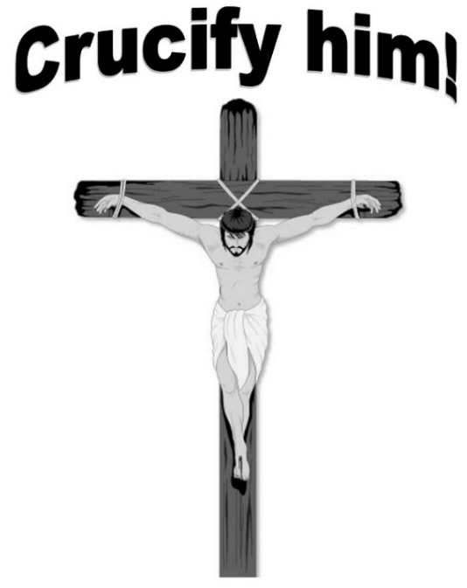

HYMN OF THE DAY - My Song is Love Unknown LBW 94

APOSTLES’ CREED
With the whole Christian church, here and around the world, we confess our faith together with the words of the Apostles’ Creed.

I believe in God, the Father almighty,
creator of heaven and earth.
I believe in Jesus Christ, God’s only Son, our Lord,
who was conceived by the Holy Spirit,
born of the virgin Mary,
suffered under Pontius Pilate,
was crucified, died, and was buried;
he descended to the dead.*
On the third day he rose again;
he ascended into heaven,
he is seated at the right hand of the Father,
and he will come to judge the living and the dead.
I believe in the Holy Spirit,
the holy catholic church,
the communion of saints,
the forgiveness of sins,
the resurrection of the body,
and the life everlasting. Amen.

PRAYERS OF INTERCESSION
Drawn close to the heart of God, we offer these prayers for the church, the world, and all who are in need.
A brief silence.
We pray for the church, called to follow Jesus in the way of the cross. Make us unflinching servants of the gospel. Deliver us from hardship as we confront the forces of injustice and practice radical compassion. Merciful God,
receive our prayer.

For the earth and all its inhabitants, created in love: Train us to recognize your divine goodness in the world around us. Rouse in us a reverence for creation, that we take greater care of its resources. Merciful God,
receive our prayer.

For those in positions of authority called to lead with integrity and compassion: Supply them with courage and vulnerability when challenged with new ideas. Deliver them from fear that limits imagination and impedes justice. Merciful God,
receive our prayer.

For those who suffer, waiting expectantly for mercy and consolation: Accompany those who feel abandoned or betrayed, defend those who are wrongly accused, and embrace those who are incarcerated or detained. Heal those who are ill (especially). Merciful God,
receive our prayer.

For Christians around the world, preparing this week to journey with Jesus to the cross: Reveal to us once again the earthshaking power of humble service, unmerited forgiveness, and sacrificial love. Lead us all from death to life. Merciful God,
receive our prayer.
We remember those who have died (especially Mikael Agricola and . . .), who were commended into your hands. Remember us when you come into your kingdom, and prepare a place for each of us with you in paradise. Merciful God,
receive our prayer.

Accept the prayers we bring, O God, on behalf of a world in need, for the sake of Jesus Christ.
Amen.

The Lord's Prayer
Our Father, who art in heaven,
hallowed be thy name,
thy kingdom come,
thy will be done,
on earth as it is in heaven.
Give us this day our daily bread;
and forgive us our trespasses,
as we forgive those
who trespass against us;
and lead us not into temptation,
but deliver us from evil.
For thine is the kingdom,
and the power, and the glory,
forever and ever. Amen.

Blessing
You are children of God, anointed with the oil of gladness and strengthened for the journey. Almighty God,
motherly, majestic, and mighty, + bless you this day and always.
Amen.

DISMISSAL
Go in peace. Jesus meets you on the way.
Thanks be to God.
V V V

Copyright © 2022 Augsburg Fortress. All rights reserved. Reprinted by permission under Augsburg Fortress Liturgies Annual License #SAS001995.

New Revised Standard Version Bible, Copyright © 1989, Division of Christian Education of the National Council of the Churches of Christ in the United States of America. Used by permission. All rights reserved.

Revised Common Lectionary, Copyright © 1992 Consultation on Common Texts, admin Augsburg Fortress. Used by permission.
V V V

Copyright Information for Hymns:

All Glory, Laud, and Honor
Text: Theodulph of Orleans, c 760-821; tr. John Mason Neale, 1818-1866, alt.
Music: VALET WILL ICH DIR GEBEN, Melchior Teschner, 1584-1635

My Song is Love Unknown
Text: Samuel Crossman, c. 1624-1683
Music: RHOSYMEDRE, John D. Edwards, 1806-1885

