MAUNDY THURSDAY
April 14, 2022

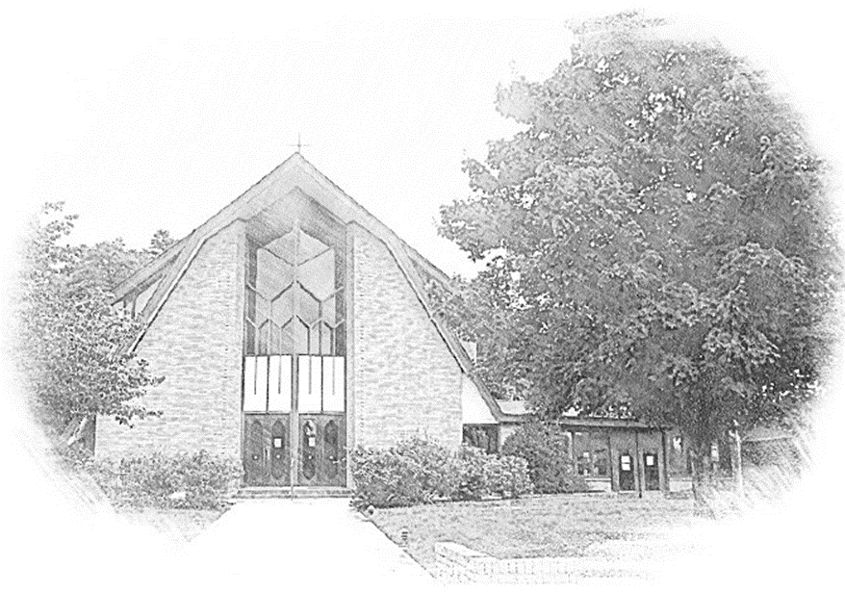

Lutheran Church of Our Saviour
Ministers: Every member of the congregation
Their Pastors: Rev. Beth Costlow & Rev. Donald Costlow
Organist: Marlon Scott
Production Staff: Harry Moose
2600 Wade Hampton Blvd
Greenville SC 29615
864.244.2836

ANNOUNCEMENTS
PRELUDE

Confession and Forgiveness
Friends in Christ, in this Lenten season we have heard our Lord’s call to struggle against sin, death, and the devil—all that keeps us from loving God and each other. This is the struggle to which we were called at baptism.
Within the community of the church, God never wearies of forgiving sin and giving the peace of reconciliation. On this night let us confess our sin against God and our neighbor, and enter the celebration of the great Three Days reconciled with God and with one another.
Most merciful God,
we confess that we are captive to sin and cannot free ourselves. We have sinned against you in thought, word, and deed, by what we have done and by what we have left undone. We have not loved you with our whole heart; we have not loved our neighbors as ourselves. For the sake of your Son, Jesus Christ, have mercy on us. Forgive us, renew us, and lead us, so that we may delight in your will and walk in your ways, to the glory of your holy name.
Amen.

In the mercy of almighty God, Jesus Christ was given to die for us, and for his sake God forgives us all our sins. As a called and ordained minister of the church of Christ, and by his authority, I therefore declare to you the entire forgiveness of all your sins, in the name of the Father, and of the ☩ Son, and of the Holy Spirit.
Amen.

Hymn: Lord, Whose Love in Humble Service ELW # 323
Greeting
The grace of our Lord Jesus Christ, the love of God, and the communion of the Holy Spirit be with you all.
And also with you.

Prayer of the Day
Eternal God, in the sharing of a meal your Son established a new covenant for all people, and in the washing of feet he showed us the dignity of service. Grant that by the power of your Holy Spirit these signs of our life in faith may speak again to our hearts, feed our spirits, and refresh our bodies, through Jesus Christ, our Savior and Lord, who lives and reigns with you and the Holy Spirit, one God, now and forever.
Amen.

First Reading: 1 Corinthians 11:23-26
A reading from First Corinthians:

²³For I received from the Lord what I also handed on to you, that the Lord Jesus on the night when he was betrayed took a loaf of bread, ²⁴and when he had given thanks, he broke it and said, “This is my body that is for you. Do this in remembrance of me.” ²⁵In the same way he took the cup also, after supper, saying, “This cup is the new covenant in my blood. Do this, as often as you drink it, in remembrance of me.” ²⁶For as often as you eat this bread and drink the cup, you proclaim the Lord’s death until he comes.

The word of the Lord.
Thanks be to God.

Gospel: John 13:1-17, 31b-35
The Holy Gospel according to St. John, the 13th chapter.
Glory to you, O Lord.

¹Now before the festival of the Passover, Jesus knew that his hour had come to depart from this world and go to the Father. Having loved his own who were in the world, he loved them to the end. ²The devil had already put it into the heart of Judas son of Simon Iscariot to betray him. And during supper ³Jesus, knowing that the Father had given all things into his hands, and that he had come from God and was going to God, ⁴got up from the table, took off his outer robe, and tied a towel around himself. ⁵Then he poured water into a basin and began to wash the disciples’ feet and to wipe them with the towel that was tied around him. ⁶He came to Simon Peter, who said to him, “Lord, are you going to wash my feet?” ⁷Jesus answered, “You do not know now what I am doing, but later you will understand.” ⁸Peter said to him, “You will never wash my feet.” Jesus answered, “Unless I wash you, you have no share with me.” ⁹Simon Peter said to him, “Lord, not my feet only but also my hands and my head!” ¹⁰Jesus said to him, “One who has bathed does not need to wash, except for the feet, but is entirely clean. And you are clean, though not all of you.” ¹¹For he knew who was to betray him; for this reason he said, “Not all of you are clean.”
¹²After he had washed their feet, had put on his robe, and had returned to the table, he said to them, “Do you know what I have done to you? ¹³You call me Teacher and Lord—and you are right, for that is what I am. ¹⁴So if I, your Lord and Teacher, have washed your feet, you also ought to wash one another’s feet. ¹⁵For I have set you an example, that you also should do as I have done to you. ¹⁶Very truly, I tell you, servants are not greater than their master, nor are messengers greater than the one who sent them. ¹⁷If you know these things, you are blessed if you do them.”
^{31b}“Now the Son of Man has been glorified, and God has been glorified in him. ³²If God has been glorified in him, God will also glorify him in himself and will glorify him at once. ³³Little children, I am with you only a little longer. You will look for me; and as I said to the Jews so now I say to you, ‘Where I am going, you cannot come.’ ³⁴I give you a new commandment, that you love one another. Just as I have loved you, you also should love one another. ³⁵By this everyone will know that you are my disciples, if you have love for one another.”

The Gospel of the Lord.
Praise to you, O Christ.

Sermon

HYMN OF THE DAY: Go to Dark Gethsemane ELW # 347

PRAYERS OF INTERCESSION

In these holiest of days, we offer prayers for ourselves, our neighbors, and our world.
A brief silence.
We pray for the church around the world. Write your new commandment of love on the heart of every believer and strengthen pastors, deacons, and lay leaders in humble service for your people. Merciful God,
receive our prayer.

We pray for the good earth you have made. Protect fields, orchards, local farms, and gardens. Inspire us with the new life budding around us, that we show more care for plants and all living creatures. Merciful God,
receive our prayer.

We pray for leaders in every land. Kindle compassion and equity in all who are called to administer justice. Guide all in positions of power away from the temptations of abuse and toward work for the common good. Merciful God,
receive our prayer.

We pray for all who are in need, especially those who are incarcerated or unjustly accused. Illuminate paths to end oppression and form supportive communities gathered around a common commitment to justice and peace. Merciful God,
receive our prayer.

We pray for this congregation and all who gather to receive your body and blood this night. Fill us at this shared table and nourish us well to heed your example of grace. Send us in love to those who cannot be with us due to illness (especially). Merciful God,
receive our prayer.

We give thanks for those who have died in the faith (especially). Teach us by their example and comfort us as we mourn. Renew us by the promise of life together with you. Merciful God,
receive our prayer.

We offer to you these petitions and those we carry in our hearts, trusting in your abundant and ever-present mercy.
Amen.

Stripping of the Altar
The service concludes with the stripping of the altar while Psalm 22 is read. The assembly sits as the sacramental elements and vessels, linens, paraments, banners, and books are removed from the worship space. Afterwards, the congregation departs in silence.
V V V

From sundaysandseasons.com.
Copyright © 2021 Augsburg Fortress. All rights reserved.

Copyright © 2021 Augsburg Fortress. All rights reserved. Reprinted by permission under Augsburg Fortress Liturgies Annual License #SAS001995.

New Revised Standard Version Bible, Copyright © 1989, Division of Christian Education of the National Council of the Churches of Christ in the United States of America. Used by permission. All rights reserved.

Revised Common Lectionary, Copyright © 1992 Consultation on Common Texts, admin Augsburg Fortress. Used by permission.

Copyright Information for Hymns:
Lord, Whose Love in Humble Service
Text: Albert F. Bayly, 1901-1984
Music: BEACH SPRING, The Sacred Harp, Philadelphia, 1844; arr. Selected Hymns, 1985
Text © 1961 Oxford University Press.
Arr. © 1985 Augsburg Fortress
Duplication in any form prohibited without permission or valid license from copyright administrator.

Go to Dark Gethsemane
Text: James Montgomery, 1771-1854
Music: GETHSEMANE, Richard Redhead, 1820-1901

V V V
If you need pastoral care, please call Reverend Beth Costlow or Reverend Don Costlow.
Pastor Beth's cell phone number is 717-715-2890 and Pastor Don’s cell phone number is 717-715-4276. Their home telephone number is 864-283-6037.

