Fifth Sunday after Epiphany
January 30, 2022
Evangelical Lutheran Worship

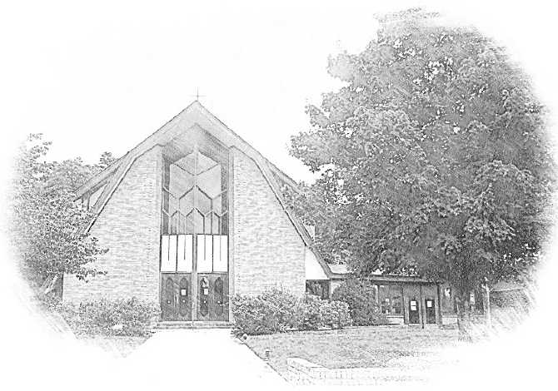

Lutheran Church of Our Saviour
Ministers: Every member of the congregation
Their Pastors: Rev. Beth Costlow & Rev. Donald Costlow
Organist: Marlon Scott
Production Staff: Harry Moose
2600 Wade Hampton Blvd
Greenville SC 29615
864.244.2836

ANNOUNCEMENTS
PRELUDE

GREETING
The grace of our Lord Jesus Christ, the Love of God, and the communion of the Holy Spirit be with you all.
And also with you.

PRAYER OF THE DAY
Most holy God, the earth is filled with your glory, and before you angels and saints stand in awe. Enlarge our vision to see your power at work in the world, and by your grace make us heralds of your Son, Jesus Christ, our Savior and Lord.
Amen.

HYMN— Holy, Holy, Holy, Lord God Almighty ELW 413
See page 6.
LESSON: Isaiah 6:1-8 [9-13]
A reading from Isaiah.

¹In the year that King Uzziah died, I saw the Lord sitting on a throne, high and lofty; and the hem of his robe filled the temple. ²Seraphs were in attendance above him; each had six wings: with two they covered their faces, and with two they covered their feet, and with two they flew. ³And one called to another and said:
“Holy, holy, holy is the Lord of hosts;
the whole earth is full of his glory.”
⁴The pivots on the thresholds shook at the voices of those who called, and the house filled with smoke. ⁵And I said: “Woe is me! I am lost, for I am a man of unclean lips, and I live among a people of unclean lips; yet my eyes have seen the King, the Lord of hosts!”
⁶Then one of the seraphs flew to me, holding a live coal that had been taken from the altar with a pair of tongs. ⁷The seraph touched my mouth with it and said: “Now that this has touched your lips, your guilt has departed and your sin is blotted out.” ⁸Then I heard the voice of the Lord saying, “Whom shall I send, and who will go for us?” And I said, “Here am I; send me!” ⁹And he said, “Go and say to this people:
‘Keep listening, but do not comprehend;
keep looking, but do not understand.’
¹⁰Make the mind of this people dull,
and stop their ears,
and shut their eyes,
so that they may not look with their eyes,
and listen with their ears,
and comprehend with their minds,
and turn and be healed.”
¹¹Then I said, “How long, O Lord?” And he said:
“Until cities lie waste
without inhabitant,
and houses without people,
and the land is utterly desolate;
¹²until the Lord sends everyone far away,
and vast is the emptiness in the midst of the land.
¹³Even if a tenth part remain in it,
it will be burned again,
like a terebinth or an oak
whose stump remains standing
when it is felled.”
The holy seed is its stump.

The Word of the Lord.

Thanks be to God.

GOSPEL: Luke 4:21-30
The Holy Gospel according to St. Luke, the fourth chapter.
Glory to you, O Lord.

²¹Then [Jesus] began to say to [all in the synagogue in Nazareth,] “Today this scripture has been fulfilled in your hearing.” ²²All spoke well of him and were amazed at the gracious words that came from his mouth. They said, “Is not this Joseph’s son?” ²³He said to them, “Doubtless you will quote to me this proverb, ‘Doctor, cure yourself!’ And you will say, ‘Do here also in your hometown the things that we have heard you did at Capernaum.’ ” ²⁴And he said, “Truly I tell you, no prophet is accepted in the prophet’s hometown. ²⁵But the truth is, there were many widows in Israel in the time of Elijah, when the heaven was shut up three years and six months, and there was a severe famine over all the land; ²⁶yet Elijah was sent to none of them except to a widow at Zarephath in Sidon. ²⁷There were also many lepers in Israel in the time of the prophet Elisha, and none of them was cleansed except Naaman the Syrian.” ²⁸When they heard this, all in the synagogue were filled with rage. ²⁹They got up, drove him out of the town, and led him to the brow of the hill on which their town was built, so that they might hurl him off the cliff. ³⁰But he passed through the midst of them and went on his way.
The Gospel of the Lord.
Praise to you, O Christ.

CHILDREN’S SERMON

SERMON

HYMN—Here I Am, Lord ELW 574

PRAYERS OF THE CHURCH
The Spirit of the Lord is poured out upon us in abundance; so we are bold to pray for the church, the world, and all that God has made.

A brief silence.

Guide your church in the ways of faith, hope, and love. Cultivate ministries and communities of compassion that bear witness to your enduring presence among us. God of grace,
hear our prayer.

Teach us to live in humility on the earth. Curb arrogance that leads to destruction of natural resources and disregard for future generations. Inspire the work of scientists who urge us to live in harmony with your creation. God of grace,
hear our prayer.

You are the refuge of all who seek hope and freedom. Accompany immigrants, refugees, and asylum seekers who cross borders to find safety and opportunity. Embolden leaders to draft compassionate policies on behalf of migrants and those who assist them. God of grace,
hear our prayer.

Love bears, believes, hopes, and endures all things. Comfort with your love all who are lonely, fearful, or brokenhearted. Sustain the hope of all those who suffer in body or spirit (especially). God of grace,
hear our prayer.

Your grace falls upon young and old alike. Bless the gifts of children in this congregation and in this community. Give us humble hearts to follow their leadership. Inspire us with their laughter, their insight, and their curiosity. God of grace,
hear our prayer.

We praise you for those who have gone before us and now see you face to face (especially). Abide with us in this mortal life until we rest in the arms of your neverending love. God of grace,
hear our prayer.

Since we have such great hope in your promises, O God, we lift these and all of our prayers to you in confidence and faith; through Jesus Christ our Savior.
Amen.

The Lord's Prayer
Lord, remember us in your kingdom and teach us to pray,
Our Father, who art in heaven,
hallowed be thy name,
thy kingdom come,
thy will be done,
on earth as it is in heaven.
Give us this day our daily bread;
and forgive us our trespasses,
as we forgive those
who trespass against us;
and lead us not into temptation,
but deliver us from evil.
For thine is the kingdom,
and the power, and the glory,
forever and ever. Amen.

BLESSING
The God of hope fill us with all joy and peace in believing, so that we may abound in hope by the power of the Holy Spirit, through Christ Jesus, the Word made flesh.
Amen.

DISMISSAL
Go in peace. Rejoice in Christ our Savior.
Thanks be to God.

POSTLUDE

-  
From sundaysandseasons.com.
Copyright © 2022 Augsburg Fortress. All rights reserved. Reprinted by permission under Augsburg Fortress Liturgies Annual License #SAS001995.
New Revised Standard Version Bible, Copyright © 1989, Division of Christian Education of the National Council of the Churches of Christ in the United States of America. Used by permission. All rights reserved.
Revised Common Lectionary, Copyright © 1992 Consultation on Common Texts, admin Augsburg Fortress. Used by permission.
Copyright Information for Hymns:

Holy, Holy, Holy, Lord God Almighty
Text: Harry E. Fosdick, 1878-1969
Music: CWM RHONDDA, John Hughes, 1873-1932

Joyful, Joyful, We Adore Thee
Text: Henry van Dyke, 1852-1922
Music: HYMN TO JOY, Ludwig van Beethoven, 1770-1827, adapt.

