First Sunday in Lent
March 6, 2022
Evangelical Lutheran Worship

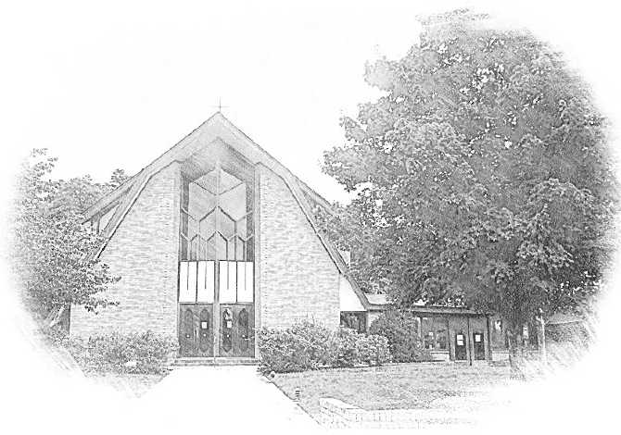

Lutheran Church of Our Saviour
Ministers: Every member of the congregation
Their Pastors: Rev. Beth Costlow & Rev. Donald Costlow
Organist: Marlon Scott
Production Staff: Harry Moose
2600 Wade Hampton Blvd
Greenville SC 29615
864.244.2836

ANNOUNCEMENTS
PRELUDE

CONFESSION AND FORGIVENESS

CONFESSION AND FORGIVENESS
All may make the sign of the cross, the sign marked at baptism, as the presiding minister begins.
In the name of God, who makes a way in the wilderness, walks with us, and guides us in our pilgrimage.
Amen.
Silence is kept for reflection. Please stand, sit, or kneel, as is comfortable for you.
Holy One,
we confess that we have wandered far from you: we have not trusted your promises, we have ignored your prophets in our own day, we have squandered our inheritance of grace, we have failed to recognize you in our midst. Have mercy on us! Forgive us and turn us again to you. Teach us to follow in your ways, assure us again of your love, and help us to love our neighbor.
Amen.

Beloved in Christ, the Word draws near to you, and all who call out to God shall be saved. In Jesus, God comes to you again and again and gathers you under wings of love. In + Jesus’ name, your sins are forgiven. God journeys with you and teaches you how to live in love.
Amen.

ENTRANCE HYMN Lord, Keep Us Steadfast in Your Word ELW 517

GREETING
The grace of our Lord Jesus Christ, the Love of God, and the communion of the Holy Spirit be with you all.
And also with you.

PRAYER OF THE DAY
Let us pray. O Lord God, you led your people through the wilderness and brought them to the promised land. Guide us now, so that, following your Son, we may walk safely through the wilderness of this world toward the life you alone can give, through Jesus Christ, our Savior and Lord, who lives and reigns with you and the Holy Spirit, one God, now and forever.
Amen

SECOND READING: Romans 10:8b-13
A Reading from Romans.

^{8b}“The word is near you,
on your lips and in your heart”
(that is, the word of faith that we proclaim); ⁹because if you confess with your lips that Jesus is Lord and believe in your heart that God raised him from the dead, you will be saved. ¹⁰For one believes with the heart and so is justified, and one confesses with the mouth and so is saved. ¹¹The scripture says, “No one who believes in him will be put to shame.” ¹²For there is no distinction between Jew and Greek; the same Lord is Lord of all and is generous to all who call on him. ¹³For, “Everyone who calls on the name of the Lord shall be saved.”

The word of the Lord.
Thanks be to God.

HOLY GOSPEL: Luke 4:1-13
The Holy Gospel according to St. Luke, the fourth chapter.
Glory to you, O Lord.

¹Jesus, full of the Holy Spirit, returned from the Jordan and was led by the Spirit in the wilderness, ²where for forty days he was tempted by the devil. He ate nothing at all during those days, and when they were over, he was famished. ³The devil said to him, “If you are the Son of God, command this stone to become a loaf of bread.” ⁴Jesus answered him, “It is written, ‘One does not live by bread alone.’ ”
⁵Then the devil led him up and showed him in an instant all the kingdoms of the world. ⁶And the devil said to him, “To you I will give their glory and all this authority; for it has been given over to me, and I give it to anyone I please. ⁷If you, then, will worship me, it will all be yours.” ⁸Jesus answered him, “It is written,
‘Worship the Lord your God,
and serve only him.’ ”
⁹Then the devil took him to Jerusalem, and placed him on the pinnacle of the temple, saying to him, “If you are the Son of God, throw yourself down from here, ¹⁰for it is written,
‘He will command his angels concerning you,
to protect you,’
¹¹and
‘On their hands they will bear you up,
so that you will not dash your foot against a stone.’ ”
¹²Jesus answered him, “It is said, ‘Do not put the Lord your God to the test.’ ” ¹³When the devil had finished every test, he departed from him until an opportune time.

The Gospel of the Lord.
Praise to you, O Christ.

CHILDREN’S SERMON

SERMON

HYMN OF THE DAY I Want Jesus to Walk with Me ELW 325

APOSTLES’ CREED

I believe in God, the Father almighty,
creator of heaven and earth.

I believe in Jesus Christ, God’s only Son, our Lord,
who was conceived by the Holy Spirit,
born of the virgin Mary,
suffered under Pontius Pilate,
was crucified, died, and was buried;
he descended to the dead.
On the third day he rose again;
he ascended into heaven,
he is seated at the right hand of the Father,
and he will come to judge the living and the dead.

I believe in the Holy Spirit,
the holy catholic church,
the communion of saints,
the forgiveness of sins,
the resurrection of the body,
and the life everlasting. Amen.

Prayers of Intercession
Drawn close to the heart of God, we offer these prayers for the church, the world, and all who are in need.

A brief silence.

We pray for the church. Sharpen its proclamation of the word so that your people learn to reject voices of deception and distraction. Strengthen all who are tempted to believe lies about themselves or others. Merciful God,
receive our prayer.

We pray for the earth and all its creatures. Protect wilderness places and all plant and animal species that call them home. Sustain farmers and all laborers who work the land and harvest the fruits of its abundance. Merciful God,
receive our prayer.

We pray for the nations of the world. Awaken elected leaders and government officials to the needs of those who are oppressed and grant them compassion to deal mercifully with immigrants and refugees who reside among us. Merciful God,
receive our prayer.

We pray for those in need. Rescue those experiencing mental illness or contending with addiction. Ease the anxiety of those who live with dementia. Command your angels concerning all who are sick (especially). Merciful God,
receive our prayer.

We pray for this assembly. Bless those who bake bread and prepare the table for our communion celebration. Accompany those who share the bounty of this meal with those who are homebound or hospitalized. Merciful God,
receive our prayer.

We give thanks for those who have died (especially). Gather them with all the saints into your heavenly dwelling place. Encourage us with the promise that all who call upon your name are saved. Merciful God,
receive our prayer.

Accept the prayers we bring, O God, on behalf of a world in need, for the sake of Jesus Christ.
Amen.

The Lord's Prayer
Lord, remember us in your kingdom and teach us to pray,
Our Father, who art in heaven,
hallowed be thy name,
thy kingdom come,
thy will be done,
on earth as it is in heaven.
Give us this day our daily bread;
and forgive us our trespasses,
as we forgive those
who trespass against us;
and lead us not into temptation,
but deliver us from evil.
For thine is the kingdom,
and the power, and the glory,
forever and ever. Amen.

Blessing
You are children of God, anointed with the oil of gladness and strengthened for the journey. Almighty God,
motherly, majestic, and mighty, ☩ bless you this day and always.
Amen.

Dismissal
Go in peace. Jesus meets you on the way.
Thanks be to God!
V V V

From sundaysandseasons.com.
Copyright © 2022 Augsburg Fortress. All rights reserved. Reprinted by permission under Augsburg Fortress Liturgies Annual License #SAS001995.
New Revised Standard Version Bible, Copyright © 1989, Division of Christian Education of the National Council of the Churches of Christ in the United States of America. Used by permission. All rights reserved.
Revised Common Lectionary, Copyright © 1992 Consultation on Common Texts, admin Augsburg Fortress. Used by permission.
Copyright Information for Hymns:

Lord, Keep Us Steadfast in Your Word
Text: Martin Luther, 1483-1546; tr. Catherine Winkworth, 1827-178, alt.
Music: ERHALT UNS, HERR, J. Klug, Geistliche Lieder, 1543

I Want Jesus to Walk with Me
Text: African American spiritual
Music: SOJOURNER, African American spiritual; arr. hymnal version
Arr. © 2006 Augsburg Fortress.
Duplication in any form prohibited without permission or valid license from copyright administrator.

