Epiphany of our Lord
January 2, 2022
Evangelical Lutheran Worship

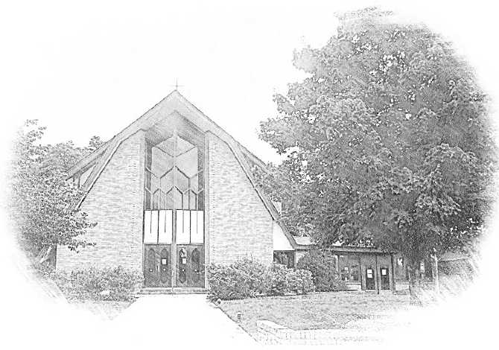

Lutheran Church of Our Saviour
Ministers: Every member of the congregation
Their Pastors: Rev. Beth Costlow & Rev. Donald Costlow
Organist: Marlon Scott
Production Staff: Harry Moose
2600 Wade Hampton Blvd
Greenville SC 29615
864.244.2836

ANNOUNCEMENTS
PRELUDE

GREETING
The grace of our Lord Jesus Christ, the Love of God, and the communion of the Holy Spirit be with you all.
And also with you.

PRAYER OF THE DAY
O God, on this day you revealed your Son to the nations by the leading of a star. Lead us now by faith to know your presence in our lives, and bring us at last to the full vision of your glory, through your Son, Jesus Christ our Lord, who lives and reigns with you and the Holy Spirit, one God, now and forever.
Amen.

HYMN— The First Noel ELW 300
See page 5.
LESSON: Isaiah 60:1-6

A reading from Isaiah.

¹Arise, shine; for your light has come,
and the glory of the Lord has risen upon you.
²For darkness shall cover the earth,
and thick darkness the peoples;
but the Lord will arise upon you,
and his glory will appear over you.
³Nations shall come to your light,
and kings to the brightness of your dawn.
⁴Lift up your eyes and look around;
they all gather together, they come to you;
your sons shall come from far away,
and your daughters shall be carried on their nurses’ arms.
⁵Then you shall see and be radiant;
your heart shall thrill and rejoice,
because the abundance of the sea shall be brought to you,
the wealth of the nations shall come to you.
⁶A multitude of camels shall cover you,
the young camels of Midian and Ephah;
all those from Sheba shall come.
They shall bring gold and frankincense,
and shall proclaim the praise of the Lord.

The Word of the Lord.

Thanks be to God.

GOSPEL: Matthew 2:1-12
The Holy Gospel according to St. Matthew, the second chapter.
Glory to you, O Lord.

¹In the time of King Herod, after Jesus was born in Bethlehem of Judea, wise men from the East came to Jerusalem, ²asking, “Where is the child who has been born king of the Jews? For we observed his star at its rising, and have come to pay him homage.” ³When King Herod heard this, he was frightened, and all Jerusalem with him; ⁴and calling together all the chief priests and scribes of the people, he inquired of them where the Messiah was to be born. ⁵They told him, “In Bethlehem of Judea; for so it has been written by the prophet:
⁶‘And you, Bethlehem, in the land of Judah,
are by no means least among the rulers of Judah;
for from you shall come a ruler
who is to shepherd my people Israel.’ ”
⁷Then Herod secretly called for the wise men and learned from them the exact time when the star had appeared. ⁸Then he sent them to Bethlehem, saying, “Go and search diligently for the child; and when you have found him, bring me word so that I may also go and pay him homage.” ⁹When they had heard the king, they set out; and there, ahead of them, went the star that they had seen at its rising, until it stopped over the place where the child was. ¹⁰When they saw that the star had stopped, they were overwhelmed with joy. ¹¹On entering the house, they saw the child with Mary his mother; and they knelt down and paid him homage. Then, opening their treasure chests, they offered him gifts of gold, frankincense, and myrrh. ¹²And having been warned in a dream not to return to Herod, they left for their own country by another road.

The Gospel of the Lord.
Praise to you, O Christ.

CHILDREN’S SERMON

SERMON

HYMN—What Child is This ELW 296
See page 6.

PRAYERS OF THE CHURCH
Joining our voices with the heavenly host and Christians throughout time and space, let us pray for the church, the world, and all in need.
A brief silence.
God of wanderers, you sent the magi from afar to witness the mystery and majesty of your birth. Send us into the world with your will in our hearts and on our lips. Merciful God,
receive our prayer.

You created heaven and earth. Through your Spirit send your all-encompassing love over the cosmos. Bless the stars that guide our way and the night sky that invites the earth into slumber. Merciful God,
receive our prayer.

You sent the magi to follow the star into an uncertain future. May all leaders and peoples seek your face, especially when paths are not clear, conflicts rage, tyrants oppress, and fear abounds. Merciful God,
receive our prayer.

You sent your Spirit to dwell with Paul in prison. Send your Spirit to those who are imprisoned and enslaved (especially). Give courage and wisdom for building roads that lead to justice and freedom. Merciful God,
receive our prayer.

You sent the holy family to seek safety in a new land. Protect all who make similar journeys. Send your guiding Spirit to asylum seekers, refugees, and all who journey toward safety. Merciful God,
receive our prayer.
Your glory is shown to the saints. We give thanks for those whose earthly journey has ended and now dwell with you forever. Give us signs of your continual presence until that day when we arise in you. Merciful God,
receive our prayer.
Rejoicing in your Word made flesh among us, we commend these prayers to you, confident of your grace and love made known to us in Jesus Christ, our Savior.
Amen.

The Lord's Prayer
Lord, remember us in your kingdom and teach us to pray,
Our Father, who art in heaven,
hallowed be thy name,
thy kingdom come,
thy will be done,
on earth as it is in heaven.
Give us this day our daily bread;
and forgive us our trespasses,
as we forgive those
who trespass against us;
and lead us not into temptation,
but deliver us from evil.
For thine is the kingdom,
and the power, and the glory,
forever and ever. Amen.

BLESSING
The God of hope fill us with all joy and peace in believing, so that we may abound in hope by the power of the Holy Spirit, through Christ Jesus, the Word made flesh.
Amen.

DISMISSAL
Go in peace. Rejoice in Christ our Savior.
Thanks be to God.

POSTLUDE

-  
From sundaysandseasons.com.
Copyright © 2022 Augsburg Fortress. All rights reserved. Reprinted by permission under Augsburg Fortress Liturgies Annual License #SAS001995.
New Revised Standard Version Bible, Copyright © 1989, Division of Christian Education of the National Council of the Churches of Christ in the United States of America. Used by permission. All rights reserved.
Revised Common Lectionary, Copyright © 1992 Consultation on Common Texts, admin Augsburg Fortress. Used by permission.

The First Noel
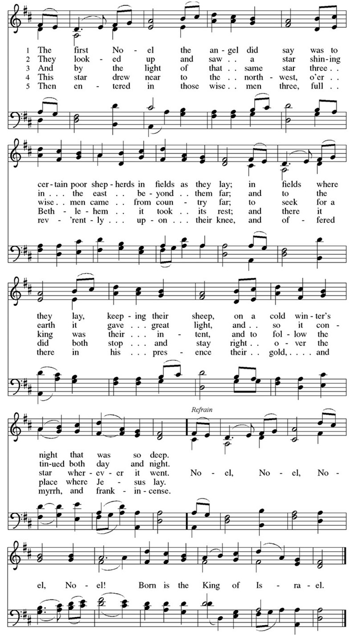

What Child is This?

Copyright Information for Hymns:

The First Noel
Text: English traditional
Music: THE FIRST NOWELL, English traditional; arr. John Stainer, 1840-1901
Text © Fortress Press, admin. Augsburg Fortress
Duplication in any form prohibited without permission or valid license from copyright administrator.

What Child is This
Text: William C. Dix, 1837-1898
Music: GREENSLEEVES, English ballad, 16th cent.

