Christ the King
November 21, 2021
Evangelical Lutheran Worship
Setting 4

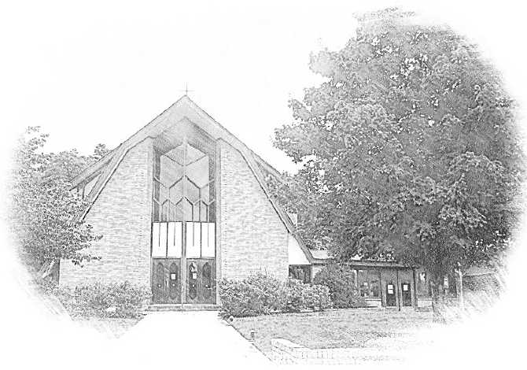

Lutheran Church of Our Saviour
Ministers: Every member of the congregation
Their Pastors: Rev. Beth Costlow & Rev. Donald Costlow
Organist: Marlon Scott
Production Staff: Harry Moose
2600 Wade Hampton Blvd
Greenville SC 29615
864.244.2836

ANNOUNCEMENTS
PRELUDE

GREETING
The grace of our Lord Jesus Christ, the Love of God, and the communion of the Holy Spirit be with you all.
And also with you.

PRAYER OF THE DAY
Almighty and ever-living God, you anointed your beloved Son to be priest and sovereign forever. Grant that all the people of the earth, now divided by the power of sin, may be united by the glorious and gentle rule of Jesus Christ, our Savior and Lord, who lives and reigns with you and the Holy Spirit, one God, now and forever.
Amen.

HYMN— Crown Him with Many Crowns (ELW 855)
See page 6.

LESSON: Revelation 1:4b-8
A reading from Revelation.

^{4b}Grace to you and peace from him who is and who was and who is to come, and from the seven spirits who are before his throne, ⁵and from Jesus Christ, the faithful witness, the firstborn of the dead, and the ruler of the kings of the earth.
To him who loves us and freed us from our sins by his blood, ⁶and made us to be a kingdom, priests serving his God and Father, to him be glory and dominion forever and ever. Amen.
⁷Look! He is coming with the clouds;
every eye will see him,
even those who pierced him;
and on his account all the tribes of the earth will wail.
So it is to be. Amen.
⁸“I am the Alpha and the Omega,” says the Lord God, who is and who was and who is to come, the Almighty.
The Word of the Lord.

Thanks be to God.

GOSPEL: John 18:33-37
The Holy Gospel according to St. John, the 18th chapter.
Glory to you, O Lord.

³³Pilate entered the headquarters again, summoned Jesus, and asked him, “Are you the King of the Jews?” ³⁴Jesus answered, “Do you ask this on your own, or did others tell you about me?” ³⁵Pilate replied, “I am not a Jew, am I? Your own nation and the chief priests have handed you over to me. What have you done?” ³⁶Jesus answered, “My kingdom is not from this world. If my kingdom were from this world, my followers would be fighting to keep me from being handed over to the Jews. But as it is, my kingdom is not from here.” ³⁷Pilate asked him, “So you are a king?” Jesus answered, “You say that I am a king. For this I was born, and for this I came into the world, to testify to the truth. Everyone who belongs to the truth listens to my voice.”

The Gospel of the Lord.
Praise to you, O Christ.

SERMON

HYMN—Lift High the Cross (ELW 660)
See page 7.

PRAYERS OF THE CHURCH
Eternal God, you hold firm amid the changes of this world. Hear us now as we pray for the church, the world, and everyone in need.

A brief silence.

God, you sent your Son Jesus to testify to the truth. We pray for preachers, missionaries, evangelists, and teachers who carry your forgiveness and love to the world. Fill their words and actions with compassion and kindness so that your truth will shine. God, in your mercy,
hear our prayer.

God, you sent your Son Jesus to liberate all of creation. We pray for all living things longing for the freedom to flourish, from ancient trees and wild grasses to endangered animals and rare insects. Give human beings compassionate hearts to care for them. God, in your mercy,
hear our prayer.

God, you sent your Son Jesus to lead us into the way of peace. Direct the members of international alliances in choosing a nonviolent path toward the future. Give them the humility and wisdom to make just decisions to benefit all. God, in your mercy,
hear our prayer.

God, you sent your Son Jesus to make us into your own people, set free to serve you. We pray for people who serve the well-being of others, especially ministries in our community (local social ministries or agencies may be named). Renew them in their work. God, in your mercy,
hear our prayer.

God, you sent your Son Jesus to rule in all times and places. We pray for the friends of our congregation who are unable to join our worship in person and for all who are sick and suffering (especially). Join their prayers with ours and unite them with us in the body of Christ. God, in your mercy,
hear our prayer.

God, you sent your Son Jesus to be our beginning and our ending. We give thanks for those whose lives have given us a glimpse of Jesus’ reign of justice and peace. Empower us to join their witness. God, in your mercy,
hear our prayer.

God our protection and strength, we entrust to you all for whom we pray. Remain with us always, through Jesus Christ, our Savior.
Amen.

The Lord's Prayer
Lord, remember us in your kingdom and teach us to pray,
Our Father, who art in heaven,
hallowed be thy name,
thy kingdom come,
thy will be done,
on earth as it is in heaven.
Give us this day our daily bread;
and forgive us our trespasses,
as we forgive those
who trespass against us;
and lead us not into temptation,
but deliver us from evil.
For thine is the kingdom,
and the power, and the glory,
forever and ever. Amen.

BLESSING
God, the beginning and the end,
who has written your name in the book of life,
☩ bless and keep you in grace and peace
from this time forth and forevermore.
Amen.

DISMISSAL
Led on by the saints before us,
go in peace to serve the Lord.
Thanks be to God.

POSTLUDE

-  
From sundaysandseasons.com.
Copyright © 2020 Augsburg Fortress. All rights reserved. Reprinted by permission under Augsburg Fortress Liturgies Annual License #SAS001995.
New Revised Standard Version Bible, Copyright © 1989, Division of Christian Education of the National Council of the Churches of Christ in the United States of America. Used by permission. All rights reserved.
Revised Common Lectionary, Copyright © 1992 Consultation on Common Texts, admin Augsburg Fortress. Used by permission.
Copyright Information for Hymns:

Crown Him with Many Crowns
Text: Matthew Bridges, 1800-1894, sts. 1-3, 5; Godfrey Thring, 1823-1903, st. 4
Music: DIADEMATA, George J. Elvey, 1816-1893

Lift High the Cross
Text: George W. Kitchin, 1827-1912; rev. Michael R. Newbolt, 1874-1956
Music: CRUCIFER, Sydney H. Nicholson, 1875-1947
Text and music © 1974 Hope Publishing Company, Carol Stream, IL 60188. All rights reserved. Used by permission.
Duplication in any form prohibited without permission or valid license from copyright administrator.

