Baptism of our Lord
January 9, 2022
Evangelical Lutheran Worship

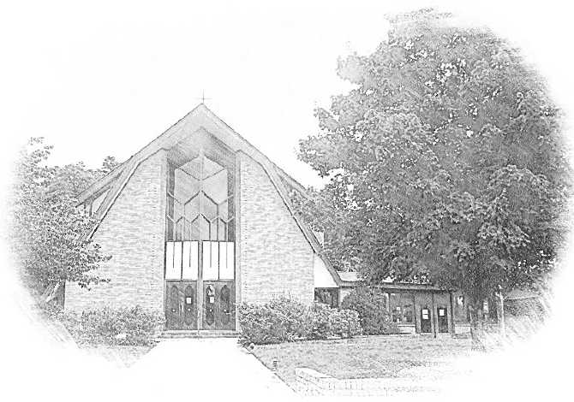

Lutheran Church of Our Saviour
Ministers: Every member of the congregation
Their Pastors: Rev. Beth Costlow & Rev. Donald Costlow
Organist: Marlon Scott
Production Staff: Harry Moose
2600 Wade Hampton Blvd
Greenville SC 29615
864.244.2836

ANNOUNCEMENTS
PRELUDE

GREETING
The grace of our Lord Jesus Christ, the Love of God, and the communion of the Holy Spirit be with you all.
And also with you.

PRAYER OF THE DAY
Almighty God, you anointed Jesus at his baptism with the Holy Spirit and revealed him as your beloved Son. Keep all who are born of water and the Spirit faithful in your service, that we may rejoice to be called children of God, through Jesus Christ, our Savior and Lord, who lives and reigns with you and the Holy Spirit, one God, now and forever.
Amen.

HYMN— Songs of Thankfulness and Praise ELW 310
See page 5.
LESSON: Acts 8:14-17

A reading from Acts.

¹⁴Now when the apostles at Jerusalem heard that Samaria had accepted the word of God, they sent Peter and John to them. ¹⁵The two went down and prayed for them that they might receive the Holy Spirit ¹⁶(for as yet the Spirit had not come upon any of them; they had only been baptized in the name of the Lord Jesus). ¹⁷Then Peter and John laid their hands on them, and they received the Holy Spirit.

The Word of the Lord.

Thanks be to God.

GOSPEL: Luke 3:15-17, 21-22
The Holy Gospel according to St. Luke, the third chapter.
Glory to you, O Lord.

¹⁵As the people were filled with expectation, and all were questioning in their hearts concerning John, whether he might be the Messiah, ¹⁶John answered all of them by saying, “I baptize you with water; but one who is more powerful than I is coming; I am not worthy to untie the thong of his sandals. He will baptize you with the Holy Spirit and fire. ¹⁷His winnowing fork is in his hand, to clear his threshing floor and to gather the wheat into his granary; but the chaff he will burn with unquenchable fire.”
²¹Now when all the people were baptized, and when Jesus also had been baptized and was praying, the heaven was opened, ²²and the Holy Spirit descended upon him in bodily form like a dove. And a voice came from heaven, “You are my Son, the Beloved; with you I am well pleased.”

The Gospel of the Lord.
Praise to you, O Christ.

CHILDREN’S SERMON

SERMON

HYMN—Spirit of Gentleness ELW 396
See page 6.

PRAYERS OF THE CHURCH
The Spirit of the Lord is poured out upon us in abundance; so we are bold to pray for the church, the world, and all that God has made.

A brief silence.

By the Holy Spirit, you gather your church and send it out in mission to share the good news of Jesus. Inspire your faithful people to be fervent in prayer and service, that all people know they are precious in God’s sight. God of grace,
hear our prayer.

You reveal your love and power through water and the Spirit. Guard rivers, seas, and all bodies of water from destruction and pollution. Secure access to clean water for all, and protect the land from drought and flood. God of grace,
hear our prayer.

Establish among the nations the blessings of peace. Raise up leaders who will protect vulnerable people in their care. Strengthen advocates who risk reputation or retaliation for the sake of mercy and justice. God of grace,
hear our prayer.

You protect us through the fires and troubled waters of this life. Assure us that we will not be cut off from you by illness or despair, anxiety or pain, confusion or weakness. Comfort all who are in need (especially). God of grace,
hear our prayer.

We are joined in baptism to Christ and to one another. Bless those who are newly baptized and those who are preparing for baptism. Help us to be faithful in fellowship, worship, evangelism, service, and justice-seeking. God of grace,
hear our prayer.

You created each of your saints for your glory. We give thanks for those you have called by name into your eternal embrace (especially). Comfort us in grief and release us from fear. God of grace,
hear our prayer.

Since we have such great hope in your promises, O God, we lift these and all of our prayers to you in confidence and faith; through Jesus Christ our Savior.
Amen.

The Lord's Prayer
Lord, remember us in your kingdom and teach us to pray,
Our Father, who art in heaven,
hallowed be thy name,
thy kingdom come,
thy will be done,
on earth as it is in heaven.
Give us this day our daily bread;
and forgive us our trespasses,
as we forgive those
who trespass against us;
and lead us not into temptation,
but deliver us from evil.
For thine is the kingdom,
and the power, and the glory,
forever and ever. Amen.

BLESSING
The God of hope fill us with all joy and peace in believing, so that we may abound in hope by the power of the Holy Spirit, through Christ Jesus, the Word made flesh.
Amen.

DISMISSAL
Go in peace. Rejoice in Christ our Savior.
Thanks be to God.

POSTLUDE

-  
From sundaysandseasons.com.
Copyright © 2022 Augsburg Fortress. All rights reserved. Reprinted by permission under Augsburg Fortress Liturgies Annual License #SAS001995.
New Revised Standard Version Bible, Copyright © 1989, Division of Christian Education of the National Council of the Churches of Christ in the United States of America. Used by permission. All rights reserved.
Revised Common Lectionary, Copyright © 1992 Consultation on Common Texts, admin Augsburg Fortress. Used by permission.

Copyright Information for Hymns:

Songs of Thankfulness and Praise
Text: Christopher Wordsworth, 1807-1885, alt.
Music: SALZBURG, Jakob Hintze, 1622-1702; arr. Johanne Sebastian Bach, 1685-1750

Spirit of Gentleness
Text: James K. Manley, b. 1940
Music: SPIRIT, James K. Manley
Text and music © 1978 James K. Manley, admin. Augsburg Fortress.
Duplication in any form prohibited without permission or valid license from copyright administrator.

Songs of Thankfulness and Praise

Spirit of Gentleness

