All Saints’ Sunday
November 7, 2021
Evangelical Lutheran Worship
Setting 4

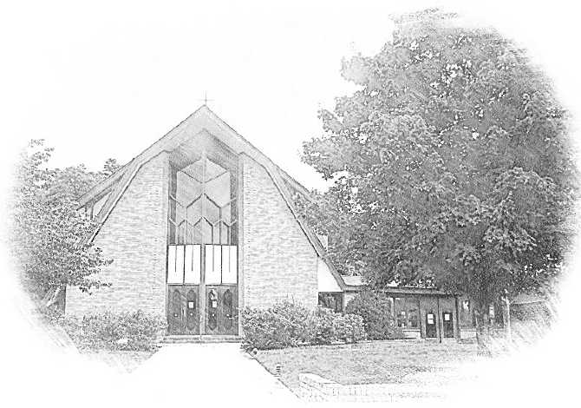

Lutheran Church of Our Saviour
Ministers: Every member of the congregation
Their Pastors: Rev. Beth Costlow & Rev. Donald Costlow
Organist: Marlon Scott
Production Staff: Harry Moose
2600 Wade Hampton Blvd
Greenville SC 29615
864.244.2836

ANNOUNCEMENTS
PRELUDE

GREETING
The grace of our Lord Jesus Christ, the Love of God, and the communion of the Holy Spirit be with you all.
And also with you.

PRAYER OF THE DAY
Almighty God, you have knit your people together in one communion in the mystical body of your Son, Jesus Christ our Lord. Grant us grace to follow your blessed saints in lives of faith and commitment, and to know the inexpressible joys you have prepared for those who love you, through Jesus Christ, our Savior and Lord, who lives and reigns with you and the Holy Spirit, one God, now and forever.
Amen.

HYMN— For All the Saints (ELW 422)
See page 6.

LESSON: Isaiah 25:6-9
A reading from Isaiah.

⁶On this mountain the Lord of hosts will make for all peoples
a feast of rich food, a feast of well-aged wines,
of rich food filled with marrow, of well-aged wines strained clear.
⁷And he will destroy on this mountain
the shroud that is cast over all peoples,
the sheet that is spread over all nations;
⁸he will swallow up death forever.
Then the Lord God will wipe away the tears from all faces,
and the disgrace of his people he will take away from all the earth,
for the Lord has spoken.
⁹It will be said on that day,
Lo, this is our God; we have waited for him, so that he might save us.
This is the Lord for whom we have waited;
let us be glad and rejoice in his salvation.

The Word of the Lord.

Thanks be to God.

GOSPEL: John 11:32-44
The Holy Gospel according to St. John, the 11th chapter.
Glory to you, O Lord.

³²When Mary came where Jesus was and saw him, she knelt at his feet and said to him, “Lord, if you had been here, my brother would not have died.” ³³When Jesus saw her weeping, and the Jews who came with her also weeping, he was greatly disturbed in spirit and deeply moved. ³⁴He said, “Where have you laid him?” They said to him, “Lord, come and see.” ³⁵Jesus began to weep. ³⁶So the Jews said, “See how he loved him!” ³⁷But some of them said, “Could not he who opened the eyes of the blind man have kept this man from dying?”
³⁸Then Jesus, again greatly disturbed, came to the tomb. It was a cave, and a stone was lying against it. ³⁹Jesus said, “Take away the stone.” Martha, the sister of the dead man, said to him, “Lord, already there is a stench because he has been dead four days.” ⁴⁰Jesus said to her, “Did I not tell you that if you believed, you would see the glory of God?” ⁴¹So they took away the stone. And Jesus looked upward and said, “Father, I thank you for having heard me. ⁴²I knew that you always hear me, but I have said this for the sake of the crowd standing here, so that they may believe that you sent me.” ⁴³When he had said this, he cried with a loud voice, “Lazarus, come out!” ⁴⁴The dead man came out, his hands and feet bound with strips of cloth, and his face wrapped in a cloth. Jesus said to them, “Unbind him, and let him go.”

The Gospel of the Lord.
Praise to you, O Christ.

SERMON

HYMN—The Church’s One Foundation (ELW 654)
See page 7.

PRAYERS OF THE CHURCH
Eternal God, you hold firm amid the changes of this world. Hear us now as we pray for the church, the world, and everyone in need.

A brief silence.

Merciful God, we give thanks for all missionaries who have brought your message of hope to new communities and wiped tears away (especially John Christian Frederick Heyer, Bartholomaeus Ziegenbalg, Ludwig Nommensen whom we commemorate today). Continue to raise up courageous missionaries to share your gospel of hope. Hear us, O God.
Your mercy is great.

Creating God, we praise you for abundant harvests and the goodness of creation. Create communities of care for your earth so that all land, water, and soil will be celebrated and cherished by future generations of saints. Hear us, O God.
Your mercy is great.

God of peace, we give you thanks for nations of peace that serve as a refuge for all whose homelands are afflicted with violence. Strengthen those who continue to work for peace and support all veterans who carry the scars of war. Hear us, O God.
Your mercy is great.

God of healing, we give you thanks for health care workers who labor around the clock to answer cries for help. Bring wholeness to all who struggle with post-traumatic stress disorder, anxiety, depression, addiction, and all who long for healing in any way (especially). Hear us, O God.
Your mercy is great.

God of justice, we praise you for the feeding ministries and for all meals that bring people together for nourishment and fellowship. Bless chefs, bakers, servers, dishwashers, communion assistants, and meal ministry coordinators. Hear us, O God.
Your mercy is great.

God of the ages, we give you thanks for the saints of this congregation who have inspired, challenged, loved, and taught us (those who have died during the past year may be named). Wipe away our tears and lead us by their example until we feast together on your holy mountain. Hear us, O God.
Your mercy is great.

God our protection and strength, we entrust to you all for whom we pray. Remain with us always, through Jesus Christ, our Savior.
Amen.

The Lord's Prayer
Lord, remember us in your kingdom and teach us to pray,
Our Father, who art in heaven,
hallowed be thy name,
thy kingdom come,
thy will be done,
on earth as it is in heaven.
Give us this day our daily bread;
and forgive us our trespasses,
as we forgive those
who trespass against us;
and lead us not into temptation,
but deliver us from evil.
For thine is the kingdom,
and the power, and the glory,
forever and ever. Amen.

BLESSING
The Lord bless you and keep you. The Lord’s face shine on you with grace and mercy. The Lord look upon you with favor and ☩ give you peace.
Amen.

DISMISSAL
Go in peace. Remember the poor.
Thanks be to God.

POSTLUDE

-  
From sundaysandseasons.com.
Copyright © 2020 Augsburg Fortress. All rights reserved. Reprinted by permission under Augsburg Fortress Liturgies Annual License #SAS001995.
New Revised Standard Version Bible, Copyright © 1989, Division of Christian Education of the National Council of the Churches of Christ in the United States of America. Used by permission. All rights reserved.
Revised Common Lectionary, Copyright © 1992 Consultation on Common Texts, admin Augsburg Fortress. Used by permission.

Copyright Information for Hymns:

For All the Saints
Text: William W. How, 1823-1897
Music: SINE NOMINE, Ralph Vaughan Williams, 1872-1958
Music from The English Hymnal outside the USA © Oxford University Press 1906. All rights reserved.
Duplication in any form prohibited without permission or valid license from copyright administrator.

The Church’s One Foundation
Text: Samuel J. Stone, 1839-1900
Music: AURELIA, Samuel S. Wesley, 1810-1876

