Fourth Sunday in Advent
December 19, 2021
Evangelical Lutheran Worship
Setting 10

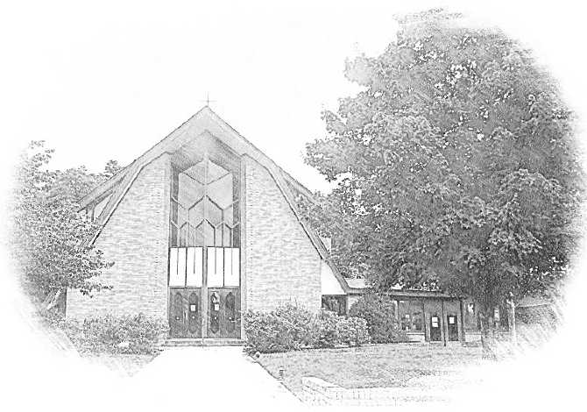

Lutheran Church of Our Saviour
Ministers: Every member of the congregation
Their Pastors: Rev. Beth Costlow & Rev. Donald Costlow
Organist: Marlon Scott
Production Staff: Harry Moose
2600 Wade Hampton Blvd
Greenville SC 29615
864.244.2836

ANNOUNCEMENTS
PRELUDE

LIGHTING OF THE ADVENT WREATH
We praise you, O God, for this circle of light that marks our days of preparation for Christ’s advent. As we light the candles on this wreath, kindle within us the fire of your Spirit, that we may be light shining in the darkness. Enlighten us with your grace, that we may welcome others as you have welcomed us. Grant this through Christ our Lord, whose coming is certain and whose day draws near.
Amen.

The fourth candle is lit while the fourth verse of the hymn is sung by a cantor.

GREETING
The grace of our Lord Jesus Christ, the Love of God, and the communion of the Holy Spirit be with you all.
And also with you.

PRAYER OF THE DAY
Stir up your power, Lord Christ, and come. With your abundant grace and might, free us from the sin that binds us, that we may receive you in joy and serve you always, for you live and reign with the Father and the Holy Spirit, one God, now and forever.
Amen.

HYMN— O Come, O Come, Emmanuel (ELW 257)

LESSON: Micah 5:2-5a
A reading from Micah.

²But you, O Bethlehem of Ephrathah,
who are one of the little clans of Judah,
from you shall come forth for me
one who is to rule in Israel,
whose origin is from of old,
from ancient days.
³Therefore he shall give them up until the time
when she who is in labor has brought forth;
then the rest of his kindred shall return
to the people of Israel.
⁴And he shall stand and feed his flock in the strength of the Lord,
in the majesty of the name of the Lord his God.
And they shall live secure, for now he shall be great
to the ends of the earth;
^{5a}and he shall be the one of peace.

The Word of the Lord.

Thanks be to God.
GOSPEL: Luke 1:39-55
The Holy Gospel according to St. Luke, the 3rd chapter.
Glory to you, O Lord.

³⁹In those days Mary set out and went with haste to a Judean town in the hill country, ⁴⁰where she entered the house of Zechariah and greeted Elizabeth. ⁴¹When Elizabeth heard Mary’s greeting, the child leaped in her womb. And Elizabeth was filled with the Holy Spirit ⁴²and exclaimed with a loud cry, “Blessed are you among women, and blessed is the fruit of your womb. ⁴³And why has this happened to me, that the mother of my Lord comes to me? ⁴⁴For as soon as I heard the sound of your greeting, the child in my womb leaped for joy. ⁴⁵And blessed is she who believed that there would be a fulfillment of what was spoken to her by the Lord.”
⁴⁶And Mary said,
“My soul magnifies the Lord,
⁴⁷and my spirit rejoices in God my Savior,
⁴⁸for he has looked with favor on the lowliness of his servant.
Surely, from now on all generations will call me blessed;
⁴⁹for the Mighty One has done great things for me,
and holy is his name.
⁵⁰His mercy is for those who fear him
from generation to generation.
⁵¹He has shown strength with his arm;
he has scattered the proud in the thoughts of their hearts.
⁵²He has brought down the powerful from their thrones,
and lifted up the lowly;
⁵³he has filled the hungry with good things,
and sent the rich away empty.
⁵⁴He has helped his servant Israel,
in remembrance of his mercy,
⁵⁵according to the promise he made to our ancestors,
to Abraham and to his descendants forever.”
The Gospel of the Lord.
Praise to you, O Christ.

CHILDREN’S SERMON

SERMON

HYMN—Savior of the Nations, Come ELW 263

PRAYERS OF THE CHURCH
In this season of watching and waiting, let us pray for all people and places that yearn for God’s presence.
A brief silence.
Nurturing God, you give us life and care for our every need. Use the church’s gifts and ministries for your service, bringing your word to all who seek your transforming grace. Hear us, O God.
Your mercy is great.

Creator God, you proclaim your boundless love for all that you have made. Renew barren lands, polluted waters, and melting ice caps. Make us servants of your creation that brings forth abundant life. Hear us, O God.
Your mercy is great.

Righteous God, you bring down the mighty and lift up the lowly. Strengthen those who seek justice. Bless the work of community organizers, activists, journalists, and all who call our attention to imbalances of power. Hear us, O God.
Your mercy is great.

Compassionate God, you proclaim your love and mercy. Show your lovingkindness to teen parents and those who are pregnant. Comfort any struggling with infertility and those who await test results, are in treatment and hospice care, and others in need (especially). Hear us, O God.
Your mercy is great.
Gracious God, you fill the hungry with good things. Bless the feeding ministries of this congregation and community. Guide us to share your bounty with those who hunger or live in poverty. Hear us, O God.
Your mercy is great.

Faithful God, you stir up the hearts of those who love you. We give you thanks for those who, like Mary, were courageous in their witness (especially). Give us such courage until that day when you fulfill all things. Hear us, O God.
Your mercy is great.

God of new life, you come among us in the places we least expect. Receive these prayers and those of our hearts, in the name of Jesus.
Amen.

The Lord's Prayer
Lord, remember us in your kingdom and teach us to pray,
Our Father, who art in heaven,
hallowed be thy name,
thy kingdom come,
thy will be done,
on earth as it is in heaven.
Give us this day our daily bread;
and forgive us our trespasses,
as we forgive those
who trespass against us;
and lead us not into temptation,
but deliver us from evil.
For thine is the kingdom,
and the power, and the glory,
forever and ever. Amen.

BLESSING
The God of hope fill us with all joy and peace in believing, so that we may abound in hope by the power of the Holy Spirit, through Christ Jesus for whom we wait.
Amen.

DISMISSAL
Go in peace. Christ is near.
Thanks be to God.

POSTLUDE

-  
From sundaysandseasons.com.
Copyright © 2021 Augsburg Fortress. All rights reserved. Reprinted by permission under Augsburg Fortress Liturgies Annual License #SAS001995.
New Revised Standard Version Bible, Copyright © 1989, Division of Christian Education of the National Council of the Churches of Christ in the United States of America. Used by permission. All rights reserved.
Revised Common Lectionary, Copyright © 1992 Consultation on Common Texts, admin Augsburg Fortress. Used by permission.

Copyright Information for Hymns:

Light One Candle
Text: Wayne L. Wold, b. 1954
Music: TIF IN VELDELE, Yiddish folk tune
Text © Fortress Press, admin. Augsburg Fortress
Duplication in any form prohibited without permission or valid license from copyright administrator.

O Come, O Come, Emmanuel
Text: Psalteriolum Cantionum Catholicarum, Koln, 1710, tr. composite
Music: VENI EMMANUEL, French processional, 15th cent.
Text st. 2 © 1997 Augsburg Fortress
Duplication in any form prohibited without permission or valid license from copyright administrator.

Savior of the Nations, Come
Text: attr. Ambrose of Milan, 340-397; Martin Luther, 1483-1546; tr. hymnal version
Music: NUN KOMM, DER HEDEN HEILAND, J. Walter, Geistliche Gesangbuchlein, 1524
Text © 2006 Augsburg Fortress

