Third Sunday in Advent
December 12, 2021
Evangelical Lutheran Worship
Setting 10

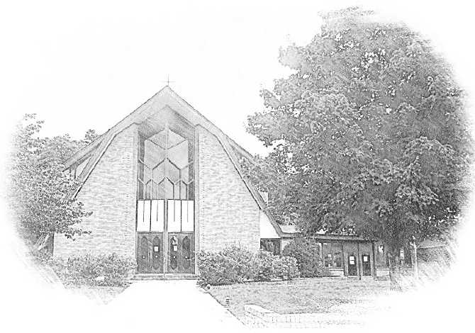

Lutheran Church of Our Saviour
Ministers: Every member of the congregation
Their Pastors: Rev. Beth Costlow & Rev. Donald Costlow
Organist: Marlon Scott
Production Staff: Harry Moose
2600 Wade Hampton Blvd
Greenville SC 29615
864.244.2836

ANNOUNCEMENTS
PRELUDE

LIGHTING OF THE ADVENT WREATH
We praise you, O God, for this circle of light that marks our days of preparation for Christ’s advent. As we light the candles on this wreath, kindle within us the fire of your Spirit, that we may be light shining in the darkness. Enlighten us with your grace, that we may welcome others as you have welcomed us. Grant this through Christ our Lord, whose coming is certain and whose day draws near.
Amen.

The third candle is lit while the third verse of the hymn is sung by a cantor.

GREETING
The grace of our Lord Jesus Christ, the Love of God, and the communion of the Holy Spirit be with you all.
And also with you.

PRAYER OF THE DAY
Stir up the wills of your faithful people, Lord God, and open our ears to the preaching of John, that, rejoicing in your salvation, we may bring forth the fruits of repentance; through Jesus Christ, our Savior and Lord, who lives and reigns with you and the Holy Spirit, one God, now and forever.
Amen.

HYMN— Rejoice, Rejoice, Believers (ELW 244)

LESSON: Isaiah 12:2-6
A reading from Isaiah.

²Surely God is my salvation; I will trust, and will not | be afraid,
for the Lord God is my strength and my might, and has become | my salvation.
³With joy you | will draw water
from the wells | of salvation.
⁴And you will say in that day: Give thanks to the Lord, call | on God’s name;
make known the deeds of the Lord among the nations; proclaim that this name | is exalted.
⁵Sing praises to the Lord, for he has done | gloriously;
let this be known in | all the earth.
⁶Shout aloud and sing for joy, O | royal Zion,
for great in your midst is the Holy | One of Israel.

The Word of the Lord.

Thanks be to God.

GOSPEL: Luke 3:7-18
The Holy Gospel according to St. Luke, the 3rd chapter.
Glory to you, O Lord.

⁷John said to the crowds that came out to be baptized by him, “You brood of vipers! Who warned you to flee from the wrath to come? ⁸Bear fruits worthy of repentance. Do not begin to say to yourselves, ‘We have Abraham as our ancestor’; for I tell you, God is able from these stones to raise up children to Abraham. ⁹Even now the ax is lying at the root of the trees; every tree therefore that does not bear good fruit is cut down and thrown into the fire.”
¹⁰And the crowds asked him, “What then should we do?” ¹¹In reply he said to them, “Whoever has two coats must share with anyone who has none; and whoever has food must do likewise.” ¹²Even tax collectors came to be baptized, and they asked him, “Teacher, what should we do?” ¹³He said to them, “Collect no more than the amount prescribed for you.” ¹⁴Soldiers also asked him, “And we, what should we do?” He said to them, “Do not extort money from anyone by threats or false accusation, and be satisfied with your wages.”
¹⁵As the people were filled with expectation, and all were questioning in their hearts concerning John, whether he might be the Messiah, ¹⁶John answered all of them by saying, “I baptize you with water; but one who is more powerful than I is coming; I am not worthy to untie the thong of his sandals. He will baptize you with the Holy Spirit and fire. ¹⁷His winnowing fork is in his hand, to clear his threshing floor and to gather the wheat into his granary; but the chaff he will burn with unquenchable fire.”
¹⁸So, with many other exhortations, he proclaimed the good news to the people.

The Gospel of the Lord.
Praise to you, O Christ.

CHILDREN’S SERMON

SERMON

HYMN—Prepare the Royal Highway ELW 264

PRAYERS OF THE CHURCH
In this season of watching and waiting, let us pray for all people and places that yearn for God’s presence.
A brief silence.
Holy God, renew your church and raise up leaders who announce your good news. Grant peace to congregations and seminarians in the midst of transition. Guide the work of candidacy and call committees. Hear us, O God.
Your mercy is great.

Creating God, your Spirit brought forth the earth and all that is in it. Breathe life into us, that we are inspired to live in harmony with one another and the planet. Hear us, O God.
Your mercy is great.

Shepherding God, you lead your people in paths of righteousness. Raise up prophets in our own day who warn against captivity to greed and point us to the freedom found in generosity. Hear us, O God.
Your mercy is great.

Nurturing God, you come near in times of worry and need. Cradle us in your arms, that we trust you and are not afraid. Attend to any who are hungry, imprisoned, or ill this day (especially). Hear us, O God.
Your mercy is great.

Rejoicing God, you exult over us in singing. Enliven the song of this assembly and bless the ministry of church musicians (especially). With instruments and dance, join our voices to the song of all creation. Hear us, O God.
Your mercy is great.

We give you thanks for your servants who showed us your goodness and grace (especially). By the power of your Spirit, keep us steadfast in faith until we make our home with you. Hear us, O God.
Your mercy is great.

God of new life, you come among us in the places we least expect. Receive these prayers and those of our hearts, in the name of Jesus.
Amen.

The Lord's Prayer
Lord, remember us in your kingdom and teach us to pray,
Our Father, who art in heaven,
hallowed be thy name,
thy kingdom come,
thy will be done,
on earth as it is in heaven.
Give us this day our daily bread;
and forgive us our trespasses,
as we forgive those
who trespass against us;
and lead us not into temptation,
but deliver us from evil.
For thine is the kingdom,
and the power, and the glory,
forever and ever. Amen.

BLESSING
The God of hope fill us with all joy and peace in believing, so that we may abound in hope by the power of the Holy Spirit, through Christ Jesus for whom we wait.
Amen.

DISMISSAL
Go in peace. Christ is near.
Thanks be to God.

POSTLUDE

-  
From sundaysandseasons.com.
Copyright © 2021 Augsburg Fortress. All rights reserved. Reprinted by permission under Augsburg Fortress Liturgies Annual License #SAS001995.
New Revised Standard Version Bible, Copyright © 1989, Division of Christian Education of the National Council of the Churches of Christ in the United States of America. Used by permission. All rights reserved.
Revised Common Lectionary, Copyright © 1992 Consultation on Common Texts, admin Augsburg Fortress. Used by permission.

Copyright Information for Hymns:

Light One Candle
Text: Wayne L. Wold, b. 1954
Music: TIF IN VELDELE, Yiddish folk tune
Text © Fortress Press, admin. Augsburg Fortress
Duplication in any form prohibited without permission or valid license from copyright administrator.

Rejoice, Rejoice, Believers
Text: Laurentius Laurenti, 1660-1722; tr. Sarah B. Findlater, 1823-1907
Music: HAF TRONES LAMPA FÄRDIG, Swedish folk tune

Prepare the Royal Highway
Text: Frans Mikael Franzen, 1772-1847; tr. Lutheran Book of Worship
Music: BEREDEN VÄG FÖR HERRAN, Swedish folk tune, 17th cent.
Text © Lutheran Book of Worship, admin. Augsburg Fortress
Duplication in any form prohibited without permission or valid license from copyright administrator.

