Second Sunday in Advent
December 5, 2021
Evangelical Lutheran Worship
Setting 10

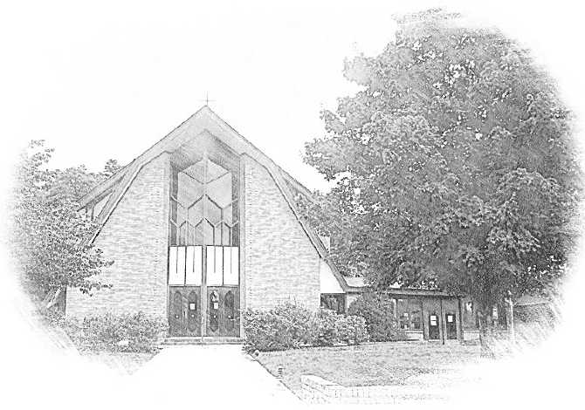

Lutheran Church of Our Saviour
Ministers: Every member of the congregation
Their Pastors: Rev. Beth Costlow & Rev. Donald Costlow
Organist: Marlon Scott
Production Staff: Harry Moose
2600 Wade Hampton Blvd
Greenville SC 29615
864.244.2836

ANNOUNCEMENTS
PRELUDE

LIGHTING OF THE ADVENT WREATH
We praise you, O God, for this circle of light that marks our days of preparation for Christ’s advent. As we light the candles on this wreath, kindle within us the fire of your Spirit, that we may be light shining in the darkness. Enlighten us with your grace, that we may welcome others as you have welcomed us. Grant this through Christ our Lord, whose coming is certain and whose day draws near.
Amen.

The first candle is lit while the second verse of the hymn is sung by a cantor.

GREETING
The grace of our Lord Jesus Christ, the Love of God, and the communion of the Holy Spirit be with you all.
And also with you.

PRAYER OF THE DAY
Stir up your power, Lord Christ, and come. By your merciful protection alert us to the threatening dangers of our sins, and redeem us for your life of justice, for you live and reign with the Father and the Holy Spirit, one God, now and forever.
Amen.

HYMN— On Jordan’s Banks the Baptist’s Cry (ELW 249)

LESSON: Malachi 3:1-4
A reading from Malachi.

¹See, I am sending my messenger to prepare the way before me, and the Lord whom you seek will suddenly come to his temple. The messenger of the covenant in whom you delight—indeed, he is coming, says the Lord of hosts. ²But who can endure the day of his coming, and who can stand when he appears?
For he is like a refiner’s fire and like fullers’ soap; ³he will sit as a refiner and purifier of silver, and he will purify the descendants of Levi and refine them like gold and silver, until they present offerings to the Lord in righteousness. ⁴Then the offering of Judah and Jerusalem will be pleasing to the Lord as in the days of old and as in former years.

The Word of the Lord.

Thanks be to God.

GOSPEL: Luke 3:1-6
The Holy Gospel according to St. Luke, the 3rd chapter.
Glory to you, O Lord.

¹In the fifteenth year of the reign of Emperor Tiberius, when Pontius Pilate was governor of Judea, and Herod was ruler of Galilee, and his brother Philip ruler of the region of Ituraea and Trachonitis, and Lysanias ruler of Abilene, ²during the high priesthood of Annas and Caiaphas, the word of God came to John son of Zechariah in the wilderness. ³He went into all the region around the Jordan, proclaiming a baptism of repentance for the forgiveness of sins, ⁴as it is written in the book of the words of the prophet Isaiah,
“The voice of one crying out in the wilderness:
‘Prepare the way of the Lord,
make his paths straight.
⁵Every valley shall be filled,
and every mountain and hill shall be made low,
and the crooked shall be made straight,
and the rough ways made smooth;
⁶and all flesh shall see the salvation of God.’ ”

The Gospel of the Lord.
Praise to you, O Christ.

CHILDREN’S SERMON

SERMON

HYMN—Come Thou Long Expected Jesus ELW 254

PRAYERS OF THE CHURCH
In this season of watching and waiting, let us pray for all people and places that yearn for God’s presence.
A brief silence.
You send messengers into the world to proclaim the day of your coming. Make our bishops, pastors, deacons, and lay preachers confident in their preaching, that their words and our lives witness to your grace. Hear us, O God.
Your mercy is great.

Send your Spirit to all living creatures that are endangered. Provide them with shelter and care, and bring us into right relationship with the earth that you create and call good. Hear us, O God.
Your mercy is great.

Send leaders to our nations, cities, schools, and businesses to work on behalf of those who have lost parents, spouses, and loved ones; immigrants; the imprisoned; those living in poverty; and all who are oppressed. Make them bold in their commitments to justice and reconciliation. Hear us, O God.
Your mercy is great.

Send your servants to care for those who suffer. Use our ministries and our lives to reach out with compassion to those who are hungry, oppressed, lonely, or ill (especially). Grant them healing and wholeness. Hear us, O God.
Your mercy is great.

Send prophets to speak difficult truths, even when they are poorly received. Embolden those who ask hard questions and challenge accepted ways. Instill in youth and elders alike a passion for pointing to Jesus in all things. Hear us, O God.
Your mercy is great.
We remember your saints, both those publicly celebrated and those more humbly remembered. Confident that your work will be completed, we live in faith until the day of your coming. Hear us, O God.
Your mercy is great.

God of new life, you come among us in the places we least expect. Receive these prayers and those of our hearts, in the name of Jesus.
Amen.

The Lord's Prayer
Lord, remember us in your kingdom and teach us to pray,
Our Father, who art in heaven,
hallowed be thy name,
thy kingdom come,
thy will be done,
on earth as it is in heaven.
Give us this day our daily bread;
and forgive us our trespasses,
as we forgive those
who trespass against us;
and lead us not into temptation,
but deliver us from evil.
For thine is the kingdom,
and the power, and the glory,
forever and ever. Amen.

BLESSING
The God of hope fill us with all joy and peace in believing, so that we may abound in hope by the power of the Holy Spirit, through Christ Jesus for whom we wait.
Amen.

DISMISSAL
Go in peace. Christ is near.
Thanks be to God.

POSTLUDE

-  
From sundaysandseasons.com.
Copyright © 2021 Augsburg Fortress. All rights reserved. Reprinted by permission under Augsburg Fortress Liturgies Annual License #SAS001995.
New Revised Standard Version Bible, Copyright © 1989, Division of Christian Education of the National Council of the Churches of Christ in the United States of America. Used by permission. All rights reserved.
Revised Common Lectionary, Copyright © 1992 Consultation on Common Texts, admin Augsburg Fortress. Used by permission.

Copyright Information for Hymns:

Light One Candle
Text: Wayne L. Wold, b. 1954
Music: TIF IN VELDELE, Yiddish folk tune
Text © Fortress Press, admin. Augsburg Fortress
Duplication in any form prohibited without permission or valid license from copyright administrator.

On Jordan’s Banks the Baptist’s Cry
Text: Charles Coffin, 1676-1749; tr. composite
Music: PUER NOBIS, European tune, adapt. Michael Praetorius, 1571-1621

Come, Thou Long Expected Jesus
Text: Charles Wesley, 1707-1788
Music: JEFFERSON, W. Walker, Southern Harmony, 1835

